Church Fenton Neighbourhood Plan

Strategic Environmental Assessment &
Habitats Regulations Assessment
Screening Report

Undertaken by Selby District Council

CONTENTS

1. Introduction

2. Legislative Background

3. SEA Screening

4. HRA Screening

5. Overall Conclusions

1 Introduction

1.1 This screening report will determine whether or not the contents of the draft Church Fenton Neighbourhood Plan (CFNP) requires a Strategic Environmental Assessment (SEA) in accordance with the European Directive 2001/42/EC and associated Environmental Assessment of Plans and Programmes Regulations 2004.

1.2 This report will also screen to determine whether or not the NP requires a Habitats Regulations Assessment in accordance with Article 6(3) of the EU Habitats Directive and with Regulation 61 of the Conservation of Habitats and Species Regulations 2010 (as amended). A HRA is required when it is deemed that likely negative significant effects may occur on protected European Sites (Natura 2000 sites) as a result of the implementation of a plan/project. As a general ‘rule of thumb’ it is identified that sites with pathways of 10-15km of the plan/project boundary should be included with a HRA.

1.3 The legislative background set out in the following section outlines the regulations that require the need for this screening exercise. Section 3, provides a screening assessment of both the likely significant environmental effects of the plan and the need for a full SEA. Section 4, provides a screening assessment of the likely significant effects of the implementation of a plan and the need for a Habitats Regulation Assessment.

2 Legislative Background

Strategic Environmental Assessment (SEA)
2.1 The basis for Strategic Environmental Assessments and Sustainability Appraisal legislation is European Directive 2001/42/EC and was transposed into English law by the Environmental Assessment of Plans and Programmes Regulations 2004, or SEA Regulations.

2.2 The 2008 Planning Act amended the requirement so only development plan documents (DPDs) need to be subject to a Sustainability Appraisal. A Neighbourhood Plan is not a development plan document and therefore does not legally require a Sustainability Appraisal. Where appropriate, however, an SEA assessment still needs to be undertaken in line with the SEA regulations.

2.3 To fulfil the legal requirement to identify if the plan requires an SEA a screening for a SEA and the criteria for establishing whether a full assessment is needed is undertaken in Chapter 3 of this report.

Habitat Regulation Assessment (HRA)
2.4 It is required by Article 6 (3) of the EU Habitats Directive and by regulation 61 of the Conservation of Habitats and Species Regulations 2010 (as amended) that an appropriate assessment is carried out with regard to the Conservation Objectives of the European Sites and with reference to other plans and projects to identify if any significant effect is likely for any European Site.

2.5 To fulfil the legal requirements to identify if likely significant effects will occur with the implementation of the plan upon the European Sites (Natura 2000 sites) a screening assessment has been undertaken in Chapter 4 of this report.

3 SEA Screening

Criteria for Assessing the Effects of the CFNP
3.1 Criteria for determining the likely significance of effects referred to in Article 3(5) of Directive 2001/42/EC are set out below:

- The characteristics of plans and programmes, having regard, in particular, to:
- the degree to which the plan or programme sets a framework for projects and other activities, either with regard to the location, nature, size and operating conditions or by allocating resources;
- the degree to which the plan or programme influences other plans and programmes including those in a hierarchy;
- the relevance of the plan or programme for the integration of environmental considerations in particular with a view to promoting sustainable development;
- environmental problems relevant to the plan or programme;
- the relevance of the plan or programme for the implementation of community legislation on the environment (e.g. plans and programmes linked to waste management or water protection).

- Characteristics of the effects and of the area likely to be affected, having regard, in particular to:
- the probability, duration, frequency and reversibility of the effects,
- the cumulative nature of the effects,
- the transboundary nature of the effects,
- the risks to human health or the environment (e.g. due to accidents),
- the magnitude and spatial extent of the effects (geographical area and size of the population likely to be affected),
- the value and vulnerability of the area likely to be affected due to:
- special natural characteristics or cultural heritage,
- exceeded environmental quality standards or limit values,
- intensive land-use,
- the effects on areas or landscapes which have a recognised national, Community or international protection status.
(Source: Annex II of SEA Directive)

3.2 The process for screening a planning document against the criteria to determine whether a full SEA is required is shown in Figure 1.

3.3 Using the process and questions set out in Figure 1, an assessment of whether the Neighbourhood Plan will require a full SEA has been undertaken and the findings are set out in Table 1.

3.4 The Environment Agency, Natural England and English Heritage were consulted on the 8 requirements for a SEA above and have given the responses in Appendix 1 of this document. All of the above have also been consulted at the pre-submission draft consultation stage.

Screening Outcome
3.5 As a result of the assessment above and the responses received from the consultees, it is unlikely there will be any significant environmental effects arising from the plan. The plan is in conformity with the Core Strategy (2013) which has been subject to a full Sustainability Appraisal, incorporating an SEA, finding no negative significant effects. Due to the nature of the plan, no sites are being allocated and the policies will have no significant effects and as such, the plan does not require a full SEA to be undertaken. TO BE CONFRIMED BY STAT CONSULTEES.

Figure 1

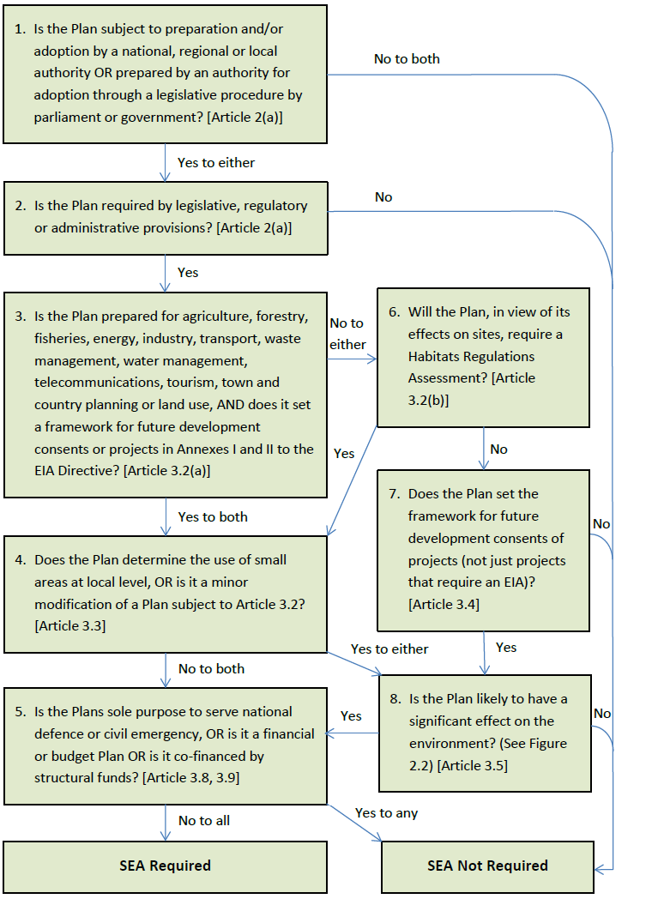

Table 1

STAGE | Y/N | REASON
- Is the PP (plan or programme) subject to preparation and/or adoption by a national, regional or local authority OR prepared by an authority for adoption through a legislative procedure by Parliament or Government (Article. 2(a)). | Y | Neighbourhood Plans are prepared by Parish Councils (as the “qualifying body”) under the provisions of the Town and Country Planning Act 1990 as amended by the Localism Act 2011. Once the Plan has been prepared, and subject to examination and referendum, it will be “made” by Selby District Council as the Local Planning Authority
- Is the PP required by legislative, regulatory or administrative provisions? (Article 2(a)). | Y | It is not a requirement for a parish to produce a Neighbourhood Plan however a Neighbourhood Plan, once “made” does form part of the statutory Development Plan and will be used when making decisions on planning applications.
3. Is the Plan prepared for agriculture, forestry, fisheries, energy, industry, transport, waste management, water management, telecommunications, tourism, town and country planning or land use, AND does it set a framework for future development consents or projects in Annexes I and II to the EIA Directive? (Article 3.2(a)) | Y | Neighbourhood Plans can cover some of the topics identified in this list and they could set the framework for development of a scale that would fall under Annex II of the EIA Directive. However for Neighbourhood Plans, developments which fall under Annex I of the EIA Directive are “excluded development” as set out in Section 61k of the Town and Country Planning Act 1990 (as amended by the Localism Act)
4. Will the PP, in view of its likely effect on sites, require an assessment for future development under Article 6 or 7 of the Habitats Directive? (Art. 3.2 (b)) |  | See screening assessment for HRA in following section of this  Report.
5. Does the Plan determine the use of small areas at local level, OR is it a minor modification of a Plan subject to Article 3.2? (Article 3.3) | N | A Neighbourhood Plan can determine the use of small areas at the local level.
6. Does the PP set the framework for future development consent of projects (not just projects in annexes to the EIA Directive)? (Art 3.4) | Y | Policies within the plan will be used in the decision making process on planning applications within the plan area.
7. Is the Plans sole purpose to serve national defence or civil emergency, OR is it a financial or budget Plan OR is it co-financed by structural funds? (Article 3.8, 3.9) | N | A Neighbourhood Plan does not deal with any of these categories of plan.
8. Is the Plan likely to have a significant effect on the environment? (Article 3.5) | N | No likely significant effects upon the environment have been  identified

4 HRA Screening

4.1 The initial screening stage of the HRA process determines if there are any likely significant effects possible as a result of the implementation of the plan and if an appropriate assessment is needed. This stage should provide a description of the plan and an identification of the Natura 2000 sites which may be affected by the plan and assess the significance of any possible effects on the identified sites.

4.2 There are no Natura 200 sites which could be affected by the proposed plan, the only SAC sites within the locality are Derwent Valley (SAC) – 18km from Church Fenton; and Skipwith Common (SAC) – 13km from Church Fenton. The Adopted Core Strategy has been assessed against a HRA assessment and has been adopted under these regulations. The proposed neighbourhood plan does not propose allocating any sites or contain any policies that would impact the SAC sites listed above.

Assessment of Effects

Screening Assessment for the Church Fenton Neighbourhood Plan
4.3 The following questions will help establish whether an Appropriate Assessment is required for the CFNP.

Is the Neighbourhood Plan directly connected with, or necessary to the management of a European site for nature conservation?

4.4 No.

Does the Neighbourhood Plan propose new development or allocate sites for development?

4.5 No.

Are there any other projects or plans that together with the Neighbourhood Plan could impact on the integrity of a European site, the ‘in combination’ impact?

4.6 No.

Screening Outcome
4.7 A full HRA of the plan is not required as it does not contain any specific development allocations or policies or proposals that would significantly affect any European site alone or in conjunction with other projects or plans.

5. Overall Conclusions

5.1 In light of the assessments undertaken above, a Strategic Environmental Assessment and a Habitats Regulations Assessment are not required for the plan. TO BE CONFIRMED BY CONSULTEES

