OULTON AND WOODLESFORD

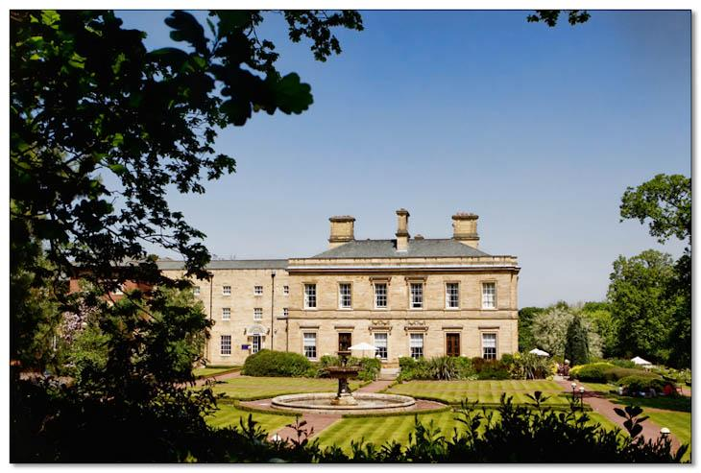

Neighbourhood Development Plan:
pre-submission consultation draft
2017 – 2033

Foreword

Oulton and Woodlesford are distinct communities that over time have grown together, to the point where it is difficult to say where one starts and one finishes. This increasing connectivity is a product of historical development, often associated with huge changes to the local landscape by industrial development. Much of that development has been progressive, providing facilities that enrich and support both communities.

As the communities have grown and changed, the attraction of the village characters of Oulton and Woodlesford has been valued and recognised by residents. As well as having official Conservation Areas, strong community groups work together to keep the local environment maintained and attractive. It is in this spirit that local residents came together to produce this draft Plan.

Development is inevitable as communities grow. However, the strongest communities are those that grow sustainably, preserving a distinctive sense of place, and improving their area over time. This Plan provides a record of what is valued by the local community in Oulton and Woodlesford, so that what gets built in the future can complement rather than compete.

The draft Neighbourhood Development Plan we are presenting to you here forms the ‘pre submission consultation draft’ and will be subject to a statutory 6-week consultaion with all our residents, businesses and external stakeholders. The feedback we receive will be used to refine the Plan where necessary and then form a new ‘submission draft’ to be sent to Leeds City Council for further consultation and eventual examination by an independent planning expert.

In time, the Plan will come back to you, the residents of Oulton and Woodlesford, to vote on in a referendum: your time to decide if this Plan should be ‘made’ and adopted by the City Council as part of the statutory Local Plan for the city. At that point the hard work of the Forum and the neighbourhood plan steering group will be realised and all future planning applications will be assessed against the policies contained therein.

Cllr Stewart Golton, Leeds City Councillor, Rothwell Ward
Professor David Cove, Chair, Oulton and Woodlesford Forum

Contents
1.0 Introduction 5
1.1 Background to the Neighbourhood Development Plan 5
1.2 The Neighbourhood Development Planning process 6
1.3 About Oulton and Woodlesford 12
1.4 How the Neighbourhood Development Plan is organised 16
2.0 Vision, objectives, themes 17
2.1 Vision 2033 17
2.2 Key objectives 17
2.3 Key themes 18
3.0 Policies for the Plan 19
3.1 Housing (H) 19
3.2 Design of the built environment (DBE) 28
3.3 Community services and facilities (CF) 32
3.4 Green environment (GE) 36
3.5 Business and economy (BE) 45
3.6 High Speed Rail (HSR)……………………………………….…………………………………………………………………..48
3.7 Policies maps……………………………………………………………………………………………………….………………..40
4.0 Projects and aspirations 52
5.0 Delivering the Plan 54
Appendix 1 Character Areas Assessment 55
Appendix 2 Key views 60
Appendix 3 Non-designated heritage Assessment………………………………………………………………..……………….65
Appendix 4 Local Green Spaces Assessment 75
Appendix 5 Community facilities assessment 85
Appendix 6 Supporting evidence……………………………………………………………………………………………………………90

Introduction

Background to the Neighbourhood Development Plan

The Localism Act, which became law in 2011, gives communities the right to produce a Neighbourhood Development Plan, which establishes general planning policies for the development and use of land in a neighbourhood, including where new homes and offices should be built and what they should look like.

At an Open Meeting held at the Oulton Institute on 28th October 2011, attended by 60 persons, including Alec Shelbrooke MP, and Rothwell Ward Councillors, David Cove presented an overview of the content of the Localism Act . Following this meeting , an informal meeting was held on 1st February 2012 to discuss the possibility of setting up a Neighbourhood Forum for Oulton and Woodlesford. There was general agreement among those present, that Woodlesford and Oulton together would make an excellent unit for local planning. Neither village on its own would be big enough, and the Rothwell district too large. A key requirement of a Neighbourhood Forum was that it should be open to all who live or work in its area, and it was therefore essential that a Forum was launched at an open public meeting that was very well advertised. It was agreed that such a meeting could not be held until details of how a Forum should be set up, had been published, and it would be especially beneficial to couple a meeting with the launch of the Village Design Statement for Oulton and Woodlesford.

The Oulton and Woodlesford Neighbourhood Forum was launched at an Inaugural General Meeting, held at the Oulton Institute on 4th November 2012. This was widely publicised in advance with notices being sent to local community groups, posters displayed widely and an article included in the Rothwell Record. The meeting was attended by over 110 residents, including the three Rothwell ward councillors and by John Hall, a member of Leeds City Council Planning Department. A motion to establish a Forum for Oulton and Woodlesford was carried without dissent and a Steering Group was elected. At this meeting a draft constitution was also adopted.

The Steering Group has met regularly (usually monthly) and has been responsible for widespread consultation and the drafting of this Neighbourhood Development Plan. After detailed consideration by the Steering Group of the draft constitution, a number of amendments were proposed and these were agreed unanimously at the Forum’s first Annual General Meeting, held on 14th April 2013.

The Constitution recognises the objectives of the Neighbourhood Forum as:

• to agree a long term vision for the Oulton and Woodlesford Neighbourhood Area.
• to promote and improve the social, economic and environmental well-being of the Oulton and Woodlesford Neighbourhood Area.
• to represent the people who live, work or carry out business in the Oulton and Woodlesford Neighbourhood Area.
• to produce a Neighbourhood Plan for the Oulton and Woodlesford Neighbourhood Area in conformity with the local development plan and the national planning policy framework.

The Neighbourhood Development Planning process
Neighbourhood planning was introduced by the government as one of a suite of “community rights” through its 2011 Localism Act. The intention was to encourage communities to take far greater control of the future of their places by determining planning policy, to integrate with the Development Plan prepared by the principal planning authority for their area – in the case of Oulton and Woodlesford that is Leeds City Council.
1.2.1 The National Planning Policy Framework
Alongside the Localism Act, the goverment published its National Planning Policy Framework (NPPF) which set out the government’s expectation that “a positive approach should be taken to achieving sustainable development through seeking economic, social and environmental gains jointly and simultaneously through the planning system”. Published in March 2012 by the Department for Communities and Local Government (DCLG), the NPPF set out the Government’s planning policies for England and how these are applied. It replaced a raft of previous guidance notes and circulars, although some do remain in place for now until further detailed policy is published. Critically, the NPPF must be taken into account in the preparation of all new local plans, including this Neighbourhood Development Plan.

The NPPF sets out a range of policies within the context of achieving sustainable development, outlining economic, social and environmental dimensions within which policies can be aligned.

1.2.2 The Leeds Local Development Framework
The Local Development Framework (LDF) is the name given to the new system of Development Plans introduced by the Planning and Compulsory Purchase Act 2004. The original Leeds Unitary Development Plan (UDP) was drawn up in the 1990s and approved in 2001; it was reviewed in 2006 and the Leeds UDP Review (2006) forms the Development Plan for Leeds until it is replaced by the emerging LDF. Rather than a single plan, the new LDF takes the form of a portfolio of documents including the following:
- Core Strategy – sets out strategic policies to 2028.
  - Site Allocations Development Plan Document – identifies land where new homes, employment and greenspaces are to be located up to 2028.
  - Aire Valley Area Action Plan - sets out plans for the area north of the Aire and to the west of the Forum’s area.
- Adopted Natural Resources and Waste Local Plan – sets out management of minerals, energy, waste and water up to 2028.
- Policies Map for Leeds – formerly known as the Proposals Map, this details the extent of relevant LDF policies.
- Community Infrastructure Levy – sets out levels of charging to be applied to different types of development in order to fund a variety of infrastructure provision.
- Neighbourhood Development Plans – provide community level frameworks.

There are also a range of Supplementary Planning Documents and Supplementary Planning Guidance retained from the Unitary Development Plan.

  - 1.2.3 The Neighbourhood Area
Following the decision of the Forum to undertake a Neighbourhood Plan, the first step on the journey was to determine the boundary for the Neighbourhood Area, the geographical area that the Plan will apply to, and to seek the approval of that Area from Leeds City Council.

In establishing the boundaries of the Oulton and Woodlesford Neighbourhood Forum, we consulted the Rothwell Neighbourhood Forum and the Methley Residents Association.

The northern border follows the River Aire and corresponds for the most part with the southern boundary of Swillington Parish Council. This boundary, in places, actually follows the historic course of the river, prior to its canalisation. This generates an anomaly, as Woodlesford lock is at present in the Swillington Parish Council’s area.
The western boundary corresponds to the eastern boundary of the Rothwell Neighbourhood Forum’s area and was agreed after discussion with the Rothwell Forum.
The southern boundary follows the M62 and corresponds to the northern boundary of Wakefield Metropolitan District.
There was no historical basis on which to define the eastern boundary, but residents of Clumpcliffe were very keen to be included in the Oulton and Woodlesford area. After a number of discussions with the Methley Residents Association (Methley has neither a Neighbourhood Forum nor a Parish Council) the boundary was agreed.
The Forum’s boundary does not correspond with that of the ecclesiastical parish boundary of Oulton with Woodlesford. The parish boundary extends into areas to the North West that are now more logically included in Rothwell.
Leeds City Council, after consultation, accepted the Forum’s boundary in July 2014 and this forms our ‘Neighbourhood Area’, within which our policies, as set out in this Plan, apply. This is illustrated in Map 1.

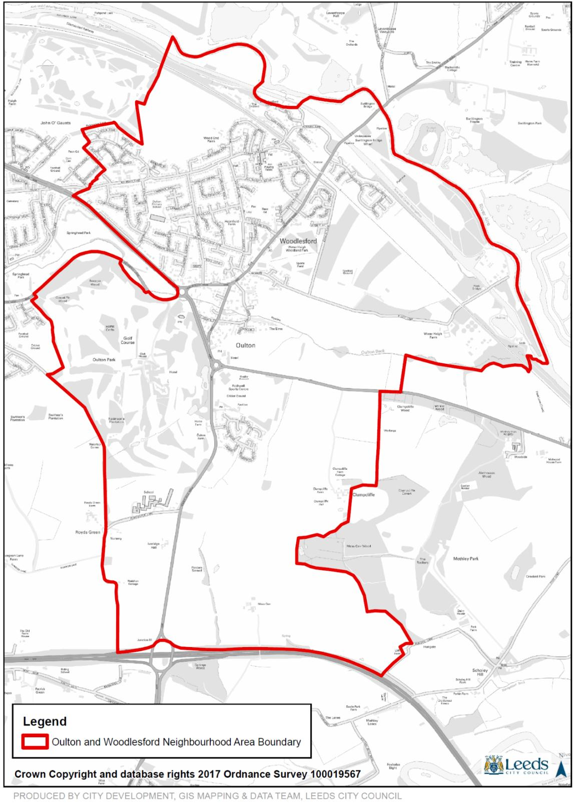
Map 1: The Oulton and Woodlesford Neighbourhood Area

1.2.4 Consulting the community
The Forum was set up at an Open General Meeting, held at the Oulton Institute on 4th November 2012. The meeting was advertised both by posters on village notice boards and in the Rothwell Record. The meeting was attended by in excess of 110 residents along with Ward Councillors Karen Bruce, Stewart Golton and David Nagle. A note of the meeting is available on the Forum’s website. At the meeting, a Steering Committee was elected and a draft Constitution adopted. The Forum’s website was set up following the meeting.
www.oawnf.org

Membership of the Forum is open to all who live, work or carry out business in the Forum’s area. There are currently 482 members of whom about two-thirds can be contacted by e-mail.
Annual General Meetings have subsequently been held on 14th April 2013, 27th April 2014, 19th April 2015 and 3rd April 2016. The minutes of these meetings are posted on the Forum’s website.
Steering Committee meetings have been held once a month. Meetings are open, are advertised by posters on village notice boards and on the Forum’s website. Minutes of meetings of the Steering Committee are also posted on the Forum’s website.
In 2014, the Steering Committee set up a number of Focus Groups, each with a member of the Steering Committee as co-ordinator. These groups included Forum members who had expressed an interest in a particular area.
An Open Meeting was held at the Oulton Institute on Sunday, 30th November 2014 to canvas input for policies emerging from Focus Groups. A record of this meeting is posted on the Forum’s website. Based on these inputs, a trial questionnaire was drafted and, in December 2014, distributed for assessment to a structured sample comprising a range of ages and residential areas. As a result of feedback from this exercise, the questionnaire was revised and distributed to all premises in the Forum’s area in March 2015. 402 completed questionnaires were received and analysed. A summary analysis is posted on the Forum’s website.
An Open Meeting was held jointly with the Oulton Society on 25th October 2015, specifically to discuss the Leeds housing Site Allocations Plan and its potential effect on the Forum’s area. Following this consultation, draft policies were produced and were displayed at two walk-in sessions in 2016. The first was held on 5th May, 2016 at the Oulton Institute, adjacent to the polling station for the local election and the second was held on 23rd June, 2016 at the Woodlesford Methodist Church, adjacent to the Polling Station for the EU referendum. At each, the public was invited to indicate whether they agreed or disagreed with each policy. Details of this consultation are posted on the Forum’s website.
1.2.5 The Plan’s progress to date
The table below sets out the progress made to date with the Plan and future steps towards the eventual external examination and referendum, when the Plan is approved or otherwise by the community and finally submitted to Leeds City Council to be adopted and become a formal part of the Local Plan.

DATE | MILESTONE
To date
November 2012 | O&W Forum decision to proceed with Neighbourhood Development Plan
March 2014 | Application for Neighbourhood Area to Leeds City Council
August 2014 | Neighbourhood Area designated by Leeds City Council
May 2015 | Consultation document sent to every household and business
July 2015 | Questionnaires completed and returned
August 2015 | Analysis of consultation
May 2016 | Drop-in session in Oulton for comment on draft policies
June 2016 | Drop-in session in Woodlesford for comment on draft policies
July 2016 | Analysis of Drop-in sessions
June 2017 | Pre submission Plan approved by the Forum’s Steering Committee
July 2017 | Informal comments sought from LCC Planning department
July 2017 | Plan sent to LCC for Strategic Environmental Assessment (SEA) screening
Nov 2017 | SEA screening opinion received from LCC – no requirement for SEA
Jan 2018 | Regulation 14 consultation with community and stakeholders
To follow
February 2018 | Revisions to the Plan
April 2018 | Plan submitted to Leeds City Council
May-June2018 | LCC Regulation 16 consultation. Examiner appointed.
July 2018 | Examination
September 2018 | Referendum

About Oulton and Woodlesford
Oulton and Woodlesford are conjoined villages at the south east urban edge of Leeds. The developed area forms a triangle where the road from Wakefield in the south divides to go on to Leeds to the north-west and Aberford to the north-east. The northern edge is defined by the Aire and Calder Navigation and the River Aire valley. Oulton occupies the southern apex of the triangle with Woodlesford to the north, the boundary between them is now indistinct.
Whilst the villages touch Rothwell to the west, they are otherwise surrounded by Green Belt with Oulton Hall, a Registered Park and Garden, to the south-west; agricultural land on the north-west and east (designated by Leeds City Council as a ‘Special Landscape Area’); recreational land to the east and wetland to the north. Oulton is relatively flat, but climbs up an east facing slope as it merges into Woodlesford, a slope which provides views to the north and east from within parts of the village.
Most of Oulton and Woodlesford is residential with two local shopping centres along Aberford Road and Church Street. With good links to Leeds via the railway, and to the motorway, the villages have become a popular residential location. Whilst green space within the built up area is scarce, provided mainly by the recreation ground, the outer edges with parks, the countryside, the river and canal provide the villages with their rural setting.
  - 1.3.1 Historical growth and development
During most of the medieval period, Oulton and Woodlesford were agricultural settlements within the Manor of Rothwell. Both villages also included associated industries - tanning, milling and smithing - and were home to cloth and linen weavers who sold to the merchants in Leeds. With the construction of the Aire and Calder Navigation of 1704 close to Woodlesford, and with Oulton at the junction of two late 18th century turnpikes, both villages had easy access to other areas from then on. As a result, further industries grew up. Stone quarrying was taking place just north of Oulton at Quarry Hill and there was a paper mill by the canal in Woodlesford, and a pottery off Pottery Lane.

Most of the land, in Oulton particularly, was owned by the Calverley family who had been in residence at Oulton Hall since 1700. It was a large farmhouse then, but during the 19th century John Calverley (who had changed his name to John Blayds) and his successors developed and improved the estate. Humphry Repton was employed in 1810 to transform the farmland around the house into Oulton Park. The house itself was then extended to designs by Robert Smirke to become the rather grander Oulton Hall but after a fire in 1850, the present Hall was rebuilt to a design by Perkins and Backhouse and extended in 1871 to designs by Chorley and Connon. The church at Oulton, St. John the Evangalist, was designed in 1829 by Rickman and Hutchinson, the leading Gothic Revival practitioners of the time.
Also in the first half of the 19th century, a few other large houses were being constructed in the area: Eshald Hall, Oulton House, Springwell Cottage, Highfield House. As the century progressed the township was established as Oulton-cum-Woodlesford, though still within Rothwell parish.
The Act authorising the building of St. John’s church was passed by parliament on 21st March 1827 and recognises “The Township of Oulton-cum-Woodlesford, within Parish of Rothwell” (Oulton did not become a separate parish until 1960, and the united parish of Oulton with Woodlesford was formed in 1975).

With the arrival of the North Midland Railway in 1838, local industry expanded further. In the latter part of the 19th century, there was a brick producing quarry to the east of the Wakefield to Aberford turnpike (now the A642 Aberford Road) owned by George Armitage and Sons and which continued in operation until the 1970s. Henry Briggs and Company opened the Water Haigh Colliery in 1908, also to the east of the A642 and south of the railway with extensive sidings linked to it. The pit was closed in 1970 and the land it covered, along with the brick quarry, has been regenerated into Water Haigh Country Park and the football pitches of the West Riding County Football Association. Henry Bentley (with a distant family connection to the famous Richard Bentley) developed Bentley’s Yorkshire Brewery at Eshald Well in 1828 and this too was connected to the railway. GB (previously Bayford) Oils’ storage depot was developed at Fleet Lane by the canal in the 1960s, with oil brought in mainly by barge and distributed by road tanker. The depot has recently closed.
All this industrial development also brought the gradual development of further housing in the village. The increasing population in the late 19th century prompted the construction of All Saints Church at Woodlesford with schools in Oulton and Woodlesford and more houses.
The gap between Woodlesford and Oulton gradually closed with, initially, terraces along Aberford Road and Quarry Hill, followed in 1927 by houses on Leeds Hill. North Lane and Holmsley Field Lane were also developed by 1938. In the late 1950s, the National Coal Board built houses at Oulton Drive and Council houses were built at All Saints. Albert Road was built in the same period.
The rest of the open land between the villages disappeared under the Eastfields, Parkways and Derwent/Langdales estates in the late 1960s, as well as the Lynwoods in the grounds of Eshald Mansions (previously Eshald House) and the Beechwoods north of Woodlesford village. More recently still, the first decade of this century saw the development the Maltings on the site of Eshald Well Brewery and of Holmsley Grange, followed by the school site filling the final gap on Holmsley Lane.
The design of the Locks development off Pottery Lane is the most recent development in the village and adds little to its architectural qualities. In addition to these large scale developments there have continued to be small infill developments throughout the village, with the Oulton area retaining more of its older buildings than Woodlesford. Most of these infill plots have been traditional in design but of particular interest have been the timber frame developments of Appleyard Arbor Homes in New Farmers Hill, Gipsy Lane and Needless Inn Lane. These are contemporary in style and date from the late 1960s through to the present day.
  - 1.3.2 Oulton and Woodlesford today
The following information taken from the 2011 Census describes the Neighbourhood Area as follows. It is a community of over 8000 residents living in 3460 households:
- Whole house or bungalow: Detached - 1056
- Whole house or bungalow: Semi-detached - 1498
- Whole house or bungalow: Terraced (including end-terrace) - 609
- Flat, maisonette or apartment: Purpose-built block of flats or tenement - 244
- Flat, maisonette or apartment: Part of converted / shared house (including bed-sits) - 36
- Flat, maisonette or apartment: In commercial building - 14
- Caravan or other mobile or temporary structure - 3

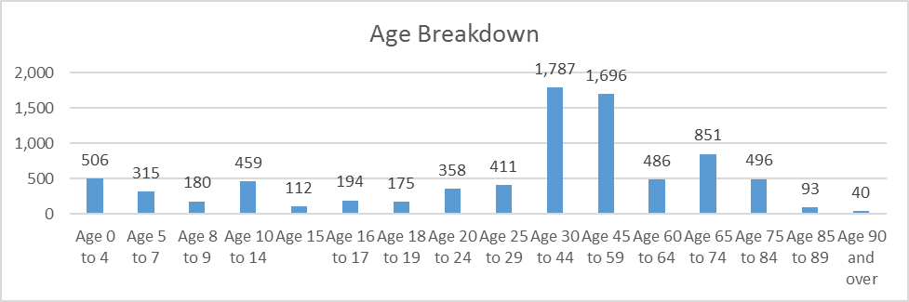
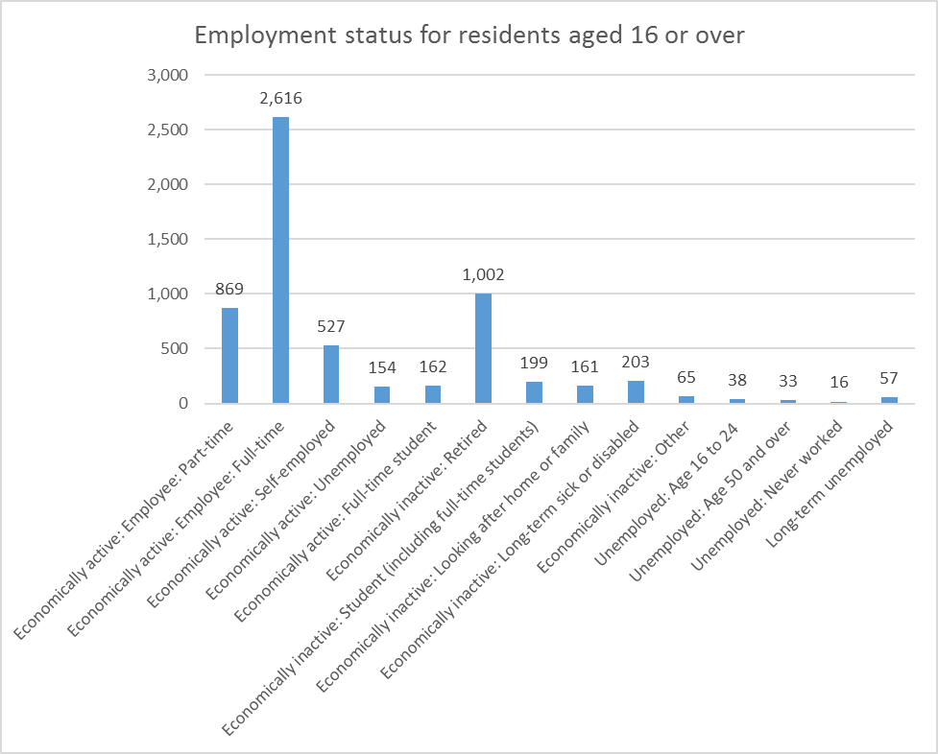
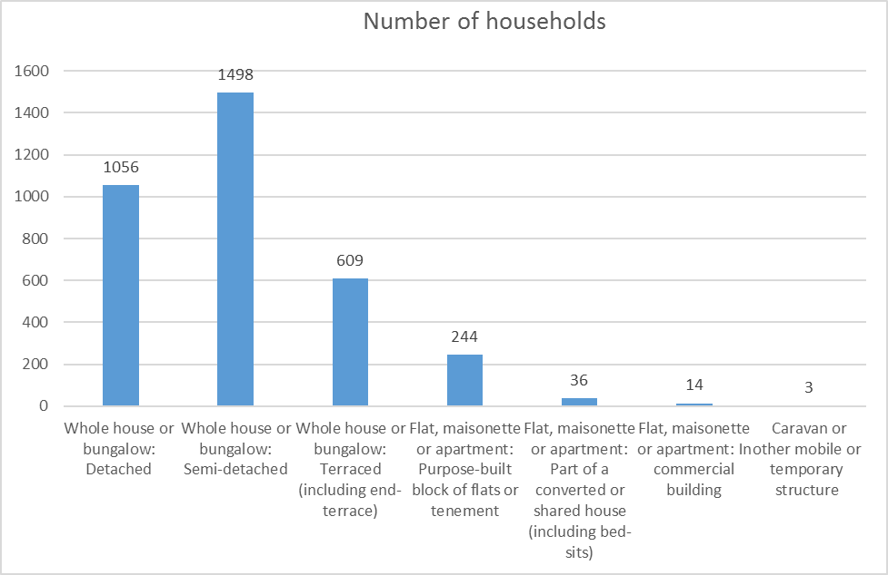

1.4 How the Neighbourhood Development Plan is organised
The Neighbourhood Development Plan is set out as follows:
- Chapter 2: The vision for the future of Oulton and Woodlesford and a set of objectives to realise that vision.
- Chapter 3: The policies for achieving the objectives substantiated by evidence and cross referenced to national and local policy, to which the policies need to broadly conform.
- Chapter 4: Sets out projects and aspirations that are analogous to the key themes and policies and that will assist in the overall delivery of the vision.
- Chapter 5: Sets out arrangements for monitoring and delivering the Plan.
- Appendices: set out materials referred to in the main body of the Plan.

The Plan in its entirety is supported by a range of evidence base documents which may be found on the website www.oawnf.org. Each policy section sets out the evidence base documents that were used to inform, substantiate and justify that policy area.

Vision, objectives, themes

Vision 2033
The Vision for the Neighborhood Area was developed through discussion of the Forum, the Neighbourhhod Plan steering group and through consultations with the wider community. The following statement reflects the views expressed:
Our vision is for Oulton and Woodlesford to be a pair of conjoined villages that share a wide range of services and facilities and offer a high quality of life through great educational, recreational and working opportunities for all. The villages have a wide range and diversity of high quality housing stock and are surrounded by high quality and accessible countryside and the well maintained and highly prized parklands. A significant feature that epitomises our twin urban and rural character is the canal corridor which now provides a wide range of excellent recreational opportunities.

2.2 Key objectives
In order to see this Vision realised, a series of key objectives have been developed:
- To encourage development of all forms that is sustainable in terms of its impact upon the natural and built environments, the community and the local economy.

- To encourage new housing development that is appropriate and complementary in design and to the needs of the communities and to the infrastructure of the area.

- To develop new facilities for the community that meet currently unmet needs and that are run for and serving the local community.

- To assist the relevant authorities in developing sustainable traffic and transport plans that seek to reduce congestion and enable movement around, in and out of the communities.

- To maintain and develop our highly prized green infrastructure assets, including parklands and canal/river corridor.

- To encourage schools and other educational facilities that provide great services.

Key themes

The policies we have developed to achieve our objectives and thereby see the Vision of the community realised are ordered into the following six key themes. Each theme has a set of policies attached to it with evidence and justification to back up those policies, including information from the consultation activities with the community that provides the foundation for driving each policy forward.

Key themes
- Housing
- Design of the built environment
- Community services and facilities
- Green environment
- Business and economy
- High Speed Rail

3.0 Policies for the Plan

3.1 Housing (H)
Policies
Purpose: To encourage developers to respond to the needs of the community and develop housing solutions that are the best fit for Oulton and Woodlesford’s residents, now and in the future. | H1a: Smaller homes  H1b: Affordable homes  H2: Design of new housing developments  H3: Design principles for identified site allocations
Objectives addressed
To encourage development of all forms that is sustainable in terms of its impact upon our natural and built environments, our community and our economy.
To encourage new housing development that is appropriate to the needs of the communities and to the infrastructure of the area.

  - 3.3.1 Smaller and affordable homes
The Leeds Core Strategy sets targets for one bedroom houses between 0% and 50% with a target of 10%, and for two bedroom houses between 30% and 80% with a target of 50%. The target for affordable homes in the Forum’s area (zone 2) is at least 15% but feedback from community members indicates that the target for the Forum’s area should be 20%.
As with so much of Leeds, the Neighbourhood Area has become unaffordable for many on lower and middle incomes, pricing many young people and families out of the area. In addition, there is evidence that affordable housing obligations may not be not delivered on site by developers, further exacerbating the affordability gap and encouraging new houses that are aimed at the executive end of the market.
The following evidence was forthcoming from consultations undertaken between 2014-2016:
2015 Survey response to “Do you think that there is enough affordable housing for first time buyers?” 68% agreed that more was needed, 24% said that there was enough.
Consultation May 2016: “Each development must contain at least 40% “affordable” homes (i.e. having only one or two bedrooms). At least half of these should be social housing.” 68 (55%) agreed, 55 (45%) disagreed.

Consultation June 2016: “Each development of more than 15 units should incorporate a minimum of 40% of homes that can be defined as affordable, that is (i) smaller dwellings, including flats and apartments; (ii) social or affordable rented homes”. 125 (69%) agreed, 57 (31%) disagreed.

Community consultations May and June 2016: “Each development must contain at least 20% of either single storied units, or two storied units adapted for independent living.” 214 (90%) agreed, 24 (10%) disagreed.

Consultation May 2016: “In each development, the affordable homes must be intermingled (“pepper-potted”) with the other homes.”. 62 (56%) agreed, 49 (44% disagreed.

Consultation June 2016: “In each development incorporating affordable homes, these should be intermingled with other homes. 110 (71%) agreed, 44 (29%) disagreed.

H1a: Smaller homes
New housing developments, containing more than 10 units, should contain at least 50% smaller homes (i.e. homes having a maximum of two bedrooms).
H1b: Affordable homes
New housing developments, containing more than 10 units, should:
- Contain at least 20% affordable homes.
- Ensure that affordable homes are intermingled (“pepper-potted”) with the other homes.
- Be delivered either on the development site or elsewhere in the Neighbourhood Area.

  - 3.3.2 Design of new housing developments
Oulton and Woodlesford have a wide range of housing types which have emerged as the villages have developed. This has given rise to positive diversity. The locality is therefore unsuitable for developments displaying uniformity and is characterised by diverse housing types and styles as the community has evolved over the years. However, each evolution has brought with it particular housing styles and character. This is arguably most evidenced in the Conservation Areas but elsewhere too, as new estates have been constructed.
The design of new housing developments has emerged from consultations as one of the key areas of concern as Oulton and Woodlesford continues to grow, with the pressures upon infrastructure and traffic in particular that this growth brings with it.
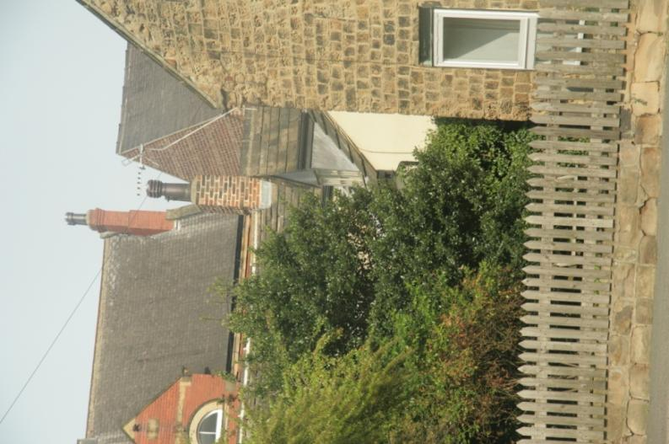
Typical village scape. Upper left, the Oulton Institute, finished in 1912; upper right, the gable and of a nineteenth century terrace; centre part of a cottage dating from the seventeenth century or earlier; right, a more recent barn conversion.

The Leeds ‘Neighbourhoods for Living’, produced by the Leeds City Council, criticises the use of generic housing designs that create “Open Plan Anywhere Suburbia” and encourages architectural variety, identifying a need to vary the limited palette of volume house builders. The Oulton and Woodlesford Neighbourhood Forum endorses these aspirations and wishes also that new developments should include single storied housing, terraces, and yards.

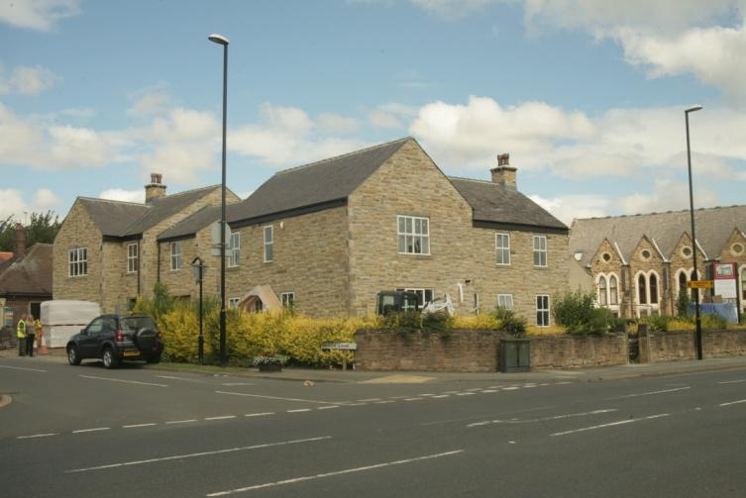
1 and 2 North Lane. A new development that is out of scale to surrounding properties. The volume of these two new houses, situated in the Oulton Conservation Area, is much larger than surrounding older properties and the roof height is substantially greater. New properties under construction in Farrer Lane have similar characteristics.

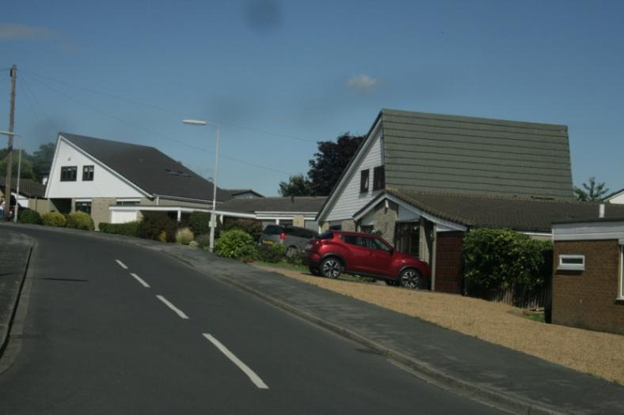

Gypsy Hill, Oulton. An early 1970s development, intermixing two storied and single storied units.

The following evidence was forthcoming from consultations undertaken between 2014-2016:
2014 consultation: Response to “I would welcome some development in Oulton and Woodlesford as long as it was sympathetic to the current look and feel of the villages.” Mean score 5.7, where 8 = “completely agree” and 1 = “completely disagree”. .

Response to “I would prefer to see a series of smaller developments around the area rather than a single large one.” Mean score 6.0 where 8 = “completely agree” and 1 = “completely disagree”.

2015 Survey response to: “I would support development in O&W, if it was sympathetic to the current look and feel of the villages.” 67% agreed or strongly agreed, 4% disagreed or strongly disagreed.

“I would prefer to see smaller developments rather than large ones.” 338 (97%) agreed or agreed strongly, 12 (3%) disagreed or disagreed strongly.

Housing Policy Intention 1 “No single development may contain more than 40 units (houses or apartments).” 281 (93%) agreed, 20 (7%) disagreed.
Consultation May/June 2016: “Developments must be sympathetic to adjoining neighbourhoods in scale and layout. Oulton and Woodlesford have a wide range of housing types which have emerged as the villages have developed. This has given rise to positive diversity. The locality is therefore unsuitable for developments with repetitive monotony. New developments must avoid “Open Plan Anywhere Suburbia” (see Leeds “Neighbourhoods for Living”) and should include single storied housing, terraces, and yards.” 257 (97%) agree, 7 (3%) disagree.

“Housing developments must include adequate off-road parking designed so that vehicles do not dominate house frontages.” 305 (96%) agree, 7 (3%) disagree.

“Housing developments must be designed with the security of residents in mind.” 260 (100%) agreed, 0 (0%) disagreed.

“New Houses and additions to existing houses must have high standards of insulation and should conform to the Passive House Standard of near carbon neutrality” 237 (98%) agreed.

“A developer must draw up a design code for any development, having carried out pre-application consultation with both local residents and with the Forum’s Steering Committee. If the developer wishes to make proposals that are at variance with consultation inputs, changes must be explained and justified.” 226 (99%) agreed, 2 (1%) disagreed.

The Leeds “Neighbourhoods for Living” document states that careful design should be used to avoid vehicles dominating housing frontages. The Leeds Street Design Guide sets out requirements for parking spaces in new developments as 2 spaces per 3 bedroomed house. Observation of parking in new developments in the Forum’s area provides evidence that this figure is now outdated, possibly because children are living with their parents for longer. Many develoments have four or five cars parked within their curtilage or on the neighbouring highway.
H2: Design of new housing developments
New housing development should have regard to the following:
- Developments should reflect the scale and layout of adjoining neighbourhoods. New developments should have individuality and avoid “Open Plan Anywhere Suburbia” and should include a mix of single storied housing, terraces, and yards.
- Developments should provide adequate off-road parking, designed so that vehicles do not dominate house frontages, either within the curtilage of new homes or through the provision of on street bays and other areas dedicated to car parking and that do not serve to clutter the street scene or act as an obstruction to the free flow of vehicles and that are located within the development site. Provision should be as follows: 1 or 2 bedroom units – 2 spaces; 3 bedroom units – 3 spaces; 4 bedroom and larger units – 4 spaces.
- Developments should be designed with the security of residents in mind.
- Developments should have high standards of insulation and should conform to the Passive House Standard of near carbon neutrality.
- House builders are encouraged to have pre-application consultation and engagement with both local residents and with the Forum’s Steering Committee. This should normally lead to a pre-application design code. If the house builder then wishes to make proposals that are at variance with consultation inputs, an opportunity to discus these with residents should be afforded.
- New housing developments should contain no more than 40 units in any phase of development, in order not to overwhelm surroundings and to encourage variety in the urban landscape.
- Each development proposal of 10 or more units should contain at least 20% of either single storied units, or two storied units adapted for independent living.

  - 3.3.3 Design principles for identified site allocations
The neighbourhood area has grown significantly over the past 20 years. As an unparished area and, until only very recently, unrepresented by an area-wide Forum, only the Oulton Society and the relatively recent Community Design Statement have been able to have direct influence from a local perspective on the shape and character of new development proposals, beyond that exerted by local Leeds City Council elected officials and representations.
Leeds City Council’s draft Site Allocation Plan (SAP) 2016 has identified the following potential sites within the Neighbourhood Area:
SAP Policy HG1 Identified Housing Sites – sites which have existing or recently expired planning permission or previously allocated housing sites.
Plan Ref | Address | Capacity
HG1-398 | Holmsley Lane – Langdale PS, Woodlesford | 3
HG1-399 | Former White Hart Hotel, 40 Church Street, Woodlesford | 7
HG1-400 | Aberford Road, Woodlesford | 41
HG1-402 | The Chapel Calverley Road, Oulton | 8
HG1-403 | Fleet Lane (land off), Oulton | 77
HG1-407 | China Red Dragon, 3 Wakefield Road, Oulton | 74
HG1-411 | Royds Geen – Royds Green Farm, Oulton | 7

In addition to these exisiting sites, the draft Site Allocations Plan identifies the following new allocations:
SAP Policy HG2 Housing Allocations – SAP allocates sites for housing and mixed use including housing.
Phase | Plan Ref | Location | Area ha | Capacity | Green/Brown
1 | HG2-176 | Windlesford Green Hostel, Woodlesford | 0.7 | 26 | Brownfield
1 | HG2-177 | Alma Villas (site at), Woodlesford | 0.7 | 12 | Min 80:20
1 | HG2-178 | Aberford Road – site of Genoit and Minerva Mills, Oulton | 2.3 | 70 | Brownfield
1 | MX2-14 | Aberford Road (77/79), Oulton | 1.1 | 36 | Brownfield
2 | HG2-179 | Fleet Lane/Eshald Lane (land at), Oulton | 1.3 | 40 | Greenfield
2 | HG2-180 | Land between Fleet Lane & Methley Lane, Oulton | 14.9 | 322 | Greenfield
2015 Survey response to “Do you think there are enough facilities in Oulton and Woodlesford for the following groups or would you like to see more? - Facilities for older people (e.g. care homes)” 174 (79%) needs more; 45 (21%) enough.
Consultations 2016: “Independent living accommodation should be provided on the Windlesford Green Hostel, Holmsley Lane (ref. HG2-176) and the 77/79 Aberford Road (Cooper’s Garage, ref. MX2-14) sites.” Agreed 67 (91%), disagreed 7 (9%). “Independent living accommodation should be provided on the Windlesford Green Hostel, Holmsley Lane (ref. HG2-176) site.” Agreed 119 (86%), disagreed 19 (14%). “Independent living accommodation should be provided on the 77/79 Aberford Road (Cooper’s Garage, ref. MX2-14) site.” Agreed 75 (54%), disagreed 63 (46%).
Recently, the Windlesford Green site has been identified by Leeds as a preferred site for extra care housing. The Forum supports this usage.
Some respondents commented that the Aberford Road site was on too busy a road for housing for the elderly. The Leeds Core Strategy, Policy H8 states “Sheltered and other housing schemes aimed at elderly or disabled people should be located within easy walking distance of town or local centres or have good access to a range of local community facilities. There is, therefore, a strong preference for the provision of independent living accommodation on the Aberford Road site because of its proximity to shops, a post office, bus routes and other facilities.

The following policy is subject to allocations made in the LCC Site Allocations Plan:

H3: Design principles for identified site allocations
Development proposals for the following locations should have regard to the following design principles:
- HG2-176. Windlesford Green Hostel, Holmsley Lane, Woodlesford: There are mature trees on the site that should be protected. Preference for this sites to be developed as flats as this would allow a higher density (possibly upto 40 units). Ground floor flats should be suitable for persons with limited mobility.

- HG2-177. Alma Villas (site of), Woodlesford LS26 8PW: There are mature trees in the site that should be protected. The site slopes and is also an awkward shape. Vehicle access via Alma Street is poor. A small part of the site is Green Belt which could be retained as green space. Development of this site could contain a larger number of smaller units than the Leeds Site Allocation Plan proposes.
- HG2-178. Aberford Road - site of Glenoit and Minerva Mills, Oulton: Small business premises would be viable on this site together with flats. By building flats instead of houses, the capacity of the site could be increased considerably. The canalside location would make it an ideal location for one or more restaurant.

- MX2-14. Aberford Road (77/79), Oulton LS26 8HS: The site is classified for mixed development. About half the site currently houses a garage and car showrooms. The southern part of the site is likely to be available and should be developed to strengthen the Oulton village hub. The site would be ideal for extra care housing. It is well situated for this, being near to shops, post office and a café and on a bus route. Such a development will increase the site’s capacity. The frontage on to Midland Street (approximately 30m) also has potential for development.

- HG2-179. Fleet Lane/Eshald Lane: The draft Site Allocations Plan identifies this site for housing, but the Forum believes this site is ideal for allotments as there are only a few allotments in the Forum’s area and a waiting list for these.

The following site is not favoured for development by the Forum but should it proceed then the following design principles should apply:

- HG2-180. Fleet Lane/Methley Lane: In the event of this development being taken forward, we do not wish to see it developed piecemeal, but instead as a number of separate developments, each containing no more than forty units. Before planning applications are submitted, the Forum wishes to reach agreement with developers for an overall plan for the area including the position of the school and traffic management. Landscaping and greenspaces which accompany any development should be carefully designed in order to mitigate the impact on the Special Landscape Area, the adjacent Conservation Area and the Green Belt. Serious consideration should also be given to the impact of HS2 which runs adjacent to the site and particularly close in the NE corner and how the impact can be mitigated.

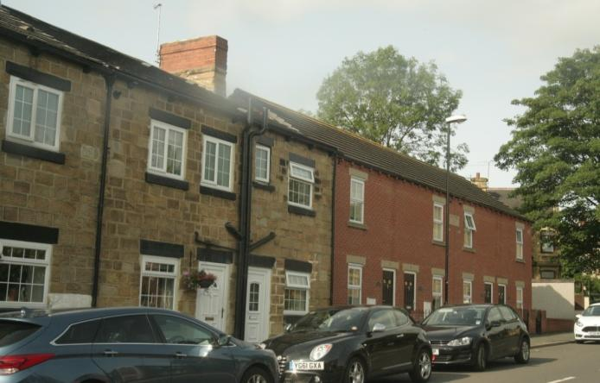
Coopers Villas, Midland Street (to right), are an excellent example of a modern infill development of small terrace houses, that have the same scale as adjacent older properties. A similar development on the Midland Street frontage of site MX2-14 would allow 5 or 6 units to be built.

3.4 Design of the built environment (DBE)

Policies (DBE)
Purpose: To develop a more cohesive community in design terms, so that the community is attractive to live, work and shop in. | DBE1: Design of the built environment  DBE2: Develop village centre shopping and leisure environments  DBE3: Protection and enhancement of local non designated heritage assets.
Objectives addressed
To encourage development of all forms, that is sustainable in terms of its impact upon our natural and built environments, our community and our economy.
To encourage new housing development that is appropriate to the needs of the communities and to the infrastructure of the area.
To develop new facilities for the community that meet currently un-met needs and that are run for and serve our local community.

  - 3.4.1 Design of the built environment
The Neighbourhood Forum, the local Civic Society and the community welcomes appropriate development and growth. However, too often in recent times development has taken place, particularly in the Conservation Areas, which the community has been opposed to. The Design Statement (2014) and the Conservation Appraisals (2010 and 2011) provide a degree of protection against inappropriate development but this needs strengthening in order to secure development which caters for the needs of the community and is in keeping with the local surroundings and landscape in a sustainable manner.
Developments along Calverley Road/Farrer Lane/Fleet Lane have changed the nature and character of these areas and have gone against the wishes of the community and local groups. In the Community consultation 99% were in favour of policies to strengthen the Forum area in line with the Design Statement and the Conservation Appraisals and management plans.

DBE1: Design of the built environment

The following principles should apply to all developments:
- Development proposals should respect local architecture and valued heritage assets.The Forum needs to consider locally distinctive designs and architecture and define it; we then need to set out these designs in a locally distinct policy. This requires further discussion - with evidence?
- Development proposals should preserve and enhance the Conservation Areas in line with the Oulton and Woodlesford Conservation Area Appraisal Management Plans.

Loss of garden setting and infill development will be resisted from development particularly in the Conservation Areas.
- Large, mature trees in gardens and on streets provide a soft backdrop for views within and into the village. These should be maintained or, where lost, be replaced on a like for like basis.
- On Pottery Lane, the Design Code produced as part of the Pottery Lane Design and Access Statement (Peter Baker Associates) should inform all future development proposals in relation to:
- Building design
- Landscape design
- Security
- Street layout and open spaces
- Building form
- Building materials and detail
- Trees and soft landscaping
- Hard landscaping and boundary treatments
- Alterations and extensions

  - 3.4.2 Develop village centre shopping and leisure environments
Oulton does not a have village centre; the shops, facilities and local community facilities are strewn across the villages and key shops mainly follow a linear pattern along Calverley Road and Aberford Road. Woodlesford has limited shops and facilities and again they are not centered together. Neither village has a cohesive, integrated high Street or parade of shops.
This high street disorder makes pedestrian access very inconvenient. This is compounded by few or no parking facilities if locals can only shop by car. There is concern from the Oulton Society and the Forum that the local street scene could be improved; there is street clutter/signage throughout that interferes with the street scene and gives the impression of an untidy and unplanned environment.
The community is essentially linked by Aberford Road which has a range of retail and food outlets but no sencse of a centre or a hub. In the Community Consultations 96% agree there should be an improvement to shop frontages and the local street scene. There is strong support for a mixed development based at Cooper’s garage Site Allocation MX2-14.
In the Leeds Core Strategy in Spatial Policy 2: Hierarchy of Centres & Spatial Approach to Retailing, Offices, Intensive Leisure & Culture, neither village is identified by the Council as having sufficient sevices or facilities to classify them as Local Centres; they are identified only as Shopping parades. The Core Strategy Page 30 Location of Development 4.1.14 states ‘Where Settlements are lacking in key services, development proposals will need to address such deficiencies’.
The Community Design Statement p.12 ARCHICTECTURE - ACTION FOR IMPROVEMENT refers to ‘The design of shop fronts should take account of the design of the building as a whole and harmonise with neighbours’.

DBE2: Develop village centre shopping and leisure environments

In order to facilitate the cohesive and sustainable growth of the Neighbourhood Area, development proposals will be welcomed which support a more integrated, high street style village centre on Aberford Road, Oulton from the Calverley Road/Aberford intersection through to Clown House (former Ritz Cinema). Developments should have regard to:

- Improved safety for pedestrians and vehicle users
- Enhanced the built environment of the street scene
- Encourage greening of the street scene
- Maintain a balance and mix between residential and commercial property
- Prioritise mixed development on any new development site in this area
- Promote commercial foot-fall through physical improvements to pedestrian access, street scene and car-parking.
- Favour new commercial activity in use classes A1-A3.

Development proposals at the commercial centre on Church Street, Woodlesford, should be in line with existing use classes in this location and support the ongoing sustainability of this smaller village centre.

  - 3.4.3 Protection and enhancement of local non designated heritage features
Despite the two Conservation Areas and significant numbers of assets that have statutory protective designations, there are, throughout the neighbourhood area, additional features that are important to the community and which are regarded as worthy of retention and, where necessary, enhancement.
The Plan steering group has undertaken investigations based upon Historic England’s database of protected assets and guidance notes and identified additional, locally important heritage assets. This is set out at Appendix 3 where, as a result of the fact that apart from Oulton Hall and St. John’s Church placed in their Repton landscape setting, the listed buildings of the historic township are not read in isolation from their neighbours and there is a constant interplay between listed buildings and those which define their context thereby creating distinctive localities within the township as a whole, the ‘non-designated heritage’ is presented in ‘groupings’ – streets, yards, courts and other types of space – whilst still making reference to specific buildings DBE3.
DBE3: Protection and enhancement of local non-designated heritage assets

The local non-designated heritage assets detailed in Appendix 3 of the Plan have been identified as being important in the local community Any development proposal that would impact upon an identified feature should consider their heritage value and have regard to how the proposal will contribute towards the sustainability of the affected asset.

3.5 Community services and facilities (CF)
Policies
Purpose: To recognise the requirements of residents and the need to have high quality facilities accesible within the community and to seek to preserve and enhance these wherever practicable. | CF1: Community facilities
 | CF2: Sports and recreation facilities
 | CF3: Educational facilities
Objectives addressed
To encourage development of all forms that is sustainable in terms of its impact upon our natural and built environments, our community and our economy.
To develop new facilities for the community that meet currently unmet needs and that are run for and serving our local community.
To maintain and develop our highly prized green infrastructure assets, including parklands and canal/river corridor.
To encourage schools and other educational facilities that provide outstanding services to the community.

  - 3.5.1 Community facilities
Consultation with the public has revealed the importance of a vibrant community sector enabling community groups to function, young people to be able to access educational opportunities on their doorstep and sports and recreational clubs and activities encouraging healthy lifestyles for all. There is a recognition of the need to invest in these facilities and, critically, to ensure there is no further erosion of local services.
Appendix 4 of the Plan sets out an assessment of important community facilities in the Neighbourhood Area, across all sectors including education, social and recreational/sports. The continuance of these facilities has been determined by the Forum as important to the sustainable future of the community, providing as they do opportunities for all sections of society without the need to travel outside the area.

CF1: Community facilities
The following community facilities will be registered as Assets of Community Value with Leeds City Council. The change of use of these facilities will only be permitted if it can be demonstrated that reasonable efforts have been made to secure their continued use for the current purposes and/or alternative provision is made:
- St John the Evangelist church, Oulton
- Methodist Church, Woodlesford
- Oulton Institute, Quarry Hill, Oulton
- All Saints Parish Hall, Woodlesford
- Methodist Chapel, Oulton
- Oulton & Woodlesford community sports club
- Rothwell Leisure Centre
- Oulton Primary School
- Woodlesford Primary School
- Royds School Specialist Language College (Foundation), Oulton

  - 3.5.2 Sports and recreation facilities
Across the Neighbourhood Area there is a distinct lack of the following facilities:
- youth club facilities
- tennis courts/ facilities/clubs
- indoor cricket nets
- squash courts
- athletics facilities/running track
- cycling clubs /facilities
The facilities the Area need to be invested in and expanded, in order to provide for a more attractive place to live and work, and critically to encourage healthier lifestyles.
The Neighbourhood Area has a number of important facilities that provide a range of opportunities for sports and recreation. These are set out below and described in more detail in Appendix 5:
- Woodlesford Park: The park consists of a pavilion for the Bowling Club and football teams, a skateboard park, children’s play area, ball court and two bowling greens (winter and summer).

- West Riding Football HQ, Fleet Lane, Oulton: This is the HQ for the West Riding Football Association. County representative matches are played here and courses for coaching, refereesand for First Aid are also held here, along with Executive Committee meetings, in the clubhouse. The Clubhouse can be hired out for social events etc. Planning approval has recently been granted for a floodlit all weather pitch.

- Rothwell Juniors Football Club, Fleet Lane, Oulton: The club caters for 35 junior teams and one open age team. The club runs both boys and girls teams and has over 400 members. Facilities consist of a new purpose built pavilion, 3 full size pitches, two seven-a-side pitches, one five-a-side pitch. There is also a floodlit 60m x 40m Astro turf pitch with enclosed fencing.
The Club hires out their facilities to a Karate group, Wakefield FC and an outside senior football team

- Oulton Hall and Park: This privately owned facility is home to a 18 hole championship Golf course and a Driving Range – both are open to the public. Golf lessons are available to all age groups. In addition, the Park offers walking trails and a private members fishing lake.
The facility also has private members Fitness and Leisure Suite – small swimming pool, fitness machines.

- Iveridge Hall: Private members Health and Fitness Club

- Fleet Lane Canal and Marina/Woodlesford Lock and Canal side: This whole area provides for low-key recreational activity in the form of Fishing/cycling/walking/bird watching, part of the Leeds Country Way/Trans Pennine Trail. It leads to the newly opened St Aidans RSPB Reserve.

g) Rothwell Leisure Centre: Provides opportunities for indoor formal sports, including gyms and swimming pools. This council centre is a very important provider of sporting facility for the area. It is available and used by the public, local sports clubs and groups and local schools.

CF2: Sports facilities
Development proposals should seek to
- Protect and enhance, as well as promote and improve accessibility to established formal sport facilities (leisure centre, sports clubs) and informal all-age exercise and play facilities.
- Encourage the provision of new and replacement sports facilities.
- Where existing facilities are improved or enhanced – for example, through the provision of a replacement Rothwell Leisure Centre – every effort should be made to ensure that disruption of services is minimised to the community and users.
- Demonstrate demand and support from the community.

  - 3.5.3 Education provision
The Neighbourhood Area has a primary school for both communities. Both schools are medium sized with under 500 pupils each. Royds School also provides secondary education for the majority of local children. Consultation with the community has revealed the importance of these local facilities to students and parents alike.
- Oulton Primary School. Recently rebuilt. About 400 pupils. Rated ‘Good’ by Ofsted in 2014.
- Woodlesford Primary School. About 475 pupils. Rated ‘Good’ by Ofsted in 2014.
- Royds School Specialist Language College (Foundation), Pennington Lane, Oulton. About 1350 pupils. Rated ‘Requires improvement’ by Ofsted in 2016.

The only library facilities in the Forum’s area is a travelling library which visits one afternoon a week. The timing of visits means that it is not accessible to school children during termtime, nor those who are employed. The nearest permanent library is found at Rothwell.

CF3: Educational facilities
Support will be given to proposals whose purpose is to facilitate the development of educational facilities, in particular:
- The growth of educational facilities on their current sites where this does not lead to the unacceptable loss of recreational open space or cause unacceptable amenity loss to neighbours.
- Proposals that deliver a public library function, supporting educational establishments in the neighbourhood area.

3.6 Green environment (GE)
Policies
Purpose: To encourage and develop a community that is more green than grey – from street scene through to parks and gardens, policy is designed to encourage strong green infrastructure wherever practicable. | GE1 Local Green Spaces  GE2a Green corridors  GE2b Green infrastructure  GE3 Protecting views in the landscape  GE4 Improve access to Public Rights of Way
Objectives addressed
To encourage development of all forms that is sustainable in terms of its impact upon our natural and built environments, our community and our economy.
To develop new facilities for the community that meet currently unmet needs and that are run for and serving our local community.
To assist the relevant authorities in developing sustainable traffic and transport plans that seek to reduce congestion and enable movement around, in and out of the communities.
To maintain and develop our highly prized green infrastructure assets, including parklands and canal/river corridor.

  - 3.6.1 Local Green Spaces
Although the neighbourhood area has some significant greenspaces on its border, the built up area itself is not a particularly greened space. The close presence of Water Haigh park, the canal corridor, Oulton Hall and Rothwell Country Park should not be confused with access to local greenspace close to where people live. In addition, the potential for loss of green countryside through future development in former special landscape area has heightened awareness of and concern for green assets.
Preliminary consultation in 2014 identified the importance of green space to the community. The questionnaire circulated in 2015 included the statement “new development should include trees or green areas”, with which 91% of responders either agreed or strongly agreed.

Our walk-in consultations in 2016 included the following statements:
- Protect, improve and enhance Local Green Space. (100% agreement).
- Support tree planting on green space and in streets. Identify and protect mature trees by obtaining Tree Preservation Orders (95% agreement).
- Identify, protect and enhance Leeds Special Landscape Area, urban Green Corridors and local Green Infrastructure (100% agreement, 248 responses).

The neighbourhood plan Steering Committee has undertaken a thorough assessment of all green spaces in the area, using the NPPF’s three criteria as the baseline for assessment. i.e:
● where the green space is in reasonably close proximity to the community it serves;
● where the green area is demonstrably special to a local community and holds a particular local significance, for example because of its beauty, historic significance, recreational value (including as a playing field), tranquillity or richness of its wildlife; and
● where the green area concerned is local in character and is not an extensive tract of land.

The following policy sets out the spaces that meet these criteria. They are further elaborated in Appendix 4 and illustrated in the Policies Map and mapping detail is set out in a separate Annex to the Plan (“Oulton and Woodlesford’s Local Green Spaces”) which shows each site map in detail.

GE1: Local Green Spaces
The following areas are designated as Local Green Spaces:
- Adjacent to no. 4 Midland Street
- Albert Road amenity green spaces
- All Saints Road amenity green space
- All Saints Road/ Eshald Place amenity green space
- Allotments, Albert Road
- Allotments, Bernard Street
- Applegarth Manor amenity green space
- Ashleigh Gardens amenity green space
- Calverley Road amenity green space
- Canal tow path,Woodlesford lock to Lemonroyd lock
- Canal-side from Woodlesford lock NW towards Leeds.
- Clumpcliffe amenity green space
- Farrer Lane amenity green space
- Fields to SE of The Maltings
- Green Lea amenity green space
- Gipsy Lane/Langdale Road amenity green space
- Holmsley Field Lane amenity green space
- Iveridge Health Club grounds
- Linwood Crescent amenity green space
- Northwood Park amenity green spaces
- Oulton Community Sports Club
- Oulton Hall Park
- Oulton Primary School playing field and grounds
- Oulton War Memorial
- Pickpocket Lane green space
- Pymont Drive amenity green space
- Quarry Hill green space
- Sherwood Way sports field
- South Oulton amenity green space
- Station lane, green space adjacent to Woodlesford Station
- Sydney Street amenity green space
- The Maltings entrance
- The Maltings amenity green space
- Water Haigh Park, canal- and river-side
- Water Haigh Park, Eshald Woods
- Water Haigh Park, Fleet Bridge Woods
- Water Haigh Park, part adjacent to Eshald Lane, SE of buildings in Aberford Road
- Water Haigh Park, West Yorkshire County and Rothwell juniors Football
- Woodlesford Park
- Woodlesford Primary School Playing and Sports field; Garden
- Woodlesford Village Green, Church Street, Woodlesford
- The buffer landscape area between Stonecroft Court Oulton and Park Road

Map 2: Local Green Spaces

  - 3.6.2 Green infrastructure and green corridors
The neighbourhood area is a mix of urban fringe suburban development but with some significant countryside and parkland on its borders. Running through the west of the area is the green corridor formed by the canal and river, incorporating part of the Trans-Pennine Trail. In addition, a section of locally (LCC) designated ‘Special Landscape Area’ exists to the south of the built up area.
The Leeds Habitat Network includes
The Network aims to protect the integrity and connectivity of areas in Leeds with nature conservation value, as well as guiding the best locations for provision of new areas and opportunities for habitat creation and enhancement. Areas around Leeds have been protected as ‘Habitats’. Once an area has been designated it cannot be built on of altered in a way that changes the effect and look of the habitat unless the developer relocates the habitat. There are several types of habitats that can be assigned including but not limited to:
- Broad-leaved and mixed Woodland
- Scrub
- Hedgerows
- (agriculturally) Unimproved/ species-rich semi-improved grassland
- Rivers/ becks, ponds, fen/ marsh and features with restoration potential such as quarries and old allotment sites
Map 2 illustrates the extent of the Network in and around the Neighbourhood Area.
There is a lack of suitable cycle lanes in the villages. Walking is popular, particularly along the canal towpaths and through other green spaces, and this should be encouraged.
Within the built up area, in particular within the Conservation Areas, there are many mature street trees and amenity green spaces of various forms from large parklands through to ‘pocket parks’.
Our walk-in consultations in 2016 included the following statements:
- Protect and enhance existing footpaths (100% agreement, 270 responses).
- Protect countryside including the canal and river (100% agreement, 343 responses).
- Walkability. Developments over 9 dwellings or 500 m² shall contribute to the general area and site specific walkability measures (100% agreement, 252 responses).
- Walkability. Provision of adequate crossing points across highways, railway and waterways. (100% agreement, 288 responses).
- Walkability. Implement 20 mph speed limits in vicinity of schools to improve safety of children (95% agreement, 287 responses).
- Walkability. Improve response time for pedestrians at road crossings (i.e. shorter wait time after pressing the button). (67% agreement, 220 responses).
- Walkability. Safe provisions for pedestrians and wheelchair users to be made on roads which lack pavements (100% agreement, 287 responses).
- Promote safe cycling and improve the local cycling infrastructure. Developments of 10 or more dwellings shall contribute to traffic free cycle routes and include covered cycle parking (e.g. as at Woodlesford station) (91% agreement, 264 responses).

GE2a: Green corridors
The following identified green corridors will be improved and protected for the multiple benefits derived from them for the community. Development proposals should not result in the disruption of the functioning of these corridors:
- Leeds Special Landscape Area
- Aire and Calder Navigation/ River Aire corridor
GE2b: Green infrastructure
Development proposals should seek to integrate strong green infrastructure, including:
- New accessible public green spaces for formal and informal recreation. New green space should seek to address identified deficits in the area and/or vicinity of the development.
- Retention of hedges, trees and landscape features.
- Retention of existing street trees and those ‘off street’ which form part of the street scene and provision of new trees wherever practicable. Existing trees in the street scene should be conserved and replaced on a like for like basis should felling be deemed inevitable.
- Provision of porous surfaces wherever hardstanding is required off the carriageway.
- Provide corridors for wildlife to move through, around or across a development site.

Map 3: Leeds Landscape Network – Oulton and Woodlesford

  - 3.6.3 Protecting views in the landscape
The character of the two Conservation Areas of the neighbourhood area are threatened by developments that might obstruct or significantly alter views into and out of these areas. The setting of Oulton Hall is of particular importance with its planned Repton landscape.
The Conservation Area Appraisals and Community Design Statement provides strong justification for maintaining the character of the built up area through ensuring new development is designed sensitively to key views.
Key views identified are listed in the policy and illustrated in Appendix 2 and in the evidence base supporting the Plan found on the website.
GE3: Protecting views in the landscape
Development proposals should respect and maintain key views across the area, as identified in the Oulton and Woodlesford Design Statement, Conservation Area Appraisals and illustrated on the Policies Map, in order to maintain the character and appearance of the area.
- Views out to the surrounding countryside are important to the east side of the Conservation Area. The flat topography is a feature of the long distance views.
- Significant views from Methley Lane to Oulton Park and the spire of St John the Evangelist Church; also across to Oulton village and its Conservation Area both from Methley Lane over Oulton Beck and from Fleet Lane with the spire again in the background.
- Panoramic views from Leeds Road to the south and west.
- The view of the spire of St John the Evangelist Church and Oulton Park from Parkways Avenue provides an interesting vista.
- Top of North Lane has excellent long distance views down the hill. The wide verges add a sense of openness.
- The tree at the junction of Quarry Hill and Midland Street is the focal point of the views down Oulton Lane.
- From Beechwood and Northwood there are dramatic views across the Aire Valley to Temple Newsam.
- The view of Woodlesford Village set on its hillside from across the river from the A642 and Bullerthorpe Lane.
- Views into the village along Aberford Road announcing arrival into Oulton.
- Views to the open countryside over the river and navigation, link Woodlesford with its setting. Leventhorpe Hall is a particular feature of these views.
- Views from Oulton Hall across Oulton, Woodlesford and the surrounding areas.
- Views of St John the Evangelist Church from St Johns Street.
- Views from Church Street, Woodlesford, to the east, which highlights the former All Saints’ Woodlesford church and the surrounding countryside.
- The view across Woodlesford Recreation Park from Oulton Lane.
- Long-distance views from Clumpcliffe across Oulton village and the surrounding countryside.

  - 3.6.4 Improve access to Public Rights of Way
There are several Public Rights of Way with pass through the Forum area. These are not always well-signposted and some have fallen into disrepair. Most significantly the Trans-Pennine Trail runs through the heart of the Neighbourhood Area on route from east to west coast of England. This route also forms part of the Leeds Country Way.
There is an active Rothwell Footpath Group based at the Oulton Institute. This has a regular walking programme. In addition, its aim is to keep a close eye on the condition of local footpaths, helping toi restore sign posting and stiles. 16 walks are identified in the Rothwell Footpath Group booklet, 4 of which pass into or across a part of the Neighbourhood Area:
- Oulton Park Perimeter Park
- Wildlife walk from Lemonroyd Marina
- Lock Marina near Woodlesford
- A Historic Park Around Rothwell-cum-Woodlesford
In addition, the Trans-Pennine Trail is a delightful traffic-free route which travels from east to west coast and, in the south/east Leeds context, connects the Neighbourhood Area with nearby Garforth and passes a nature reserve and an RSPB site along a river.
Leeds City Council opening of the new Skelton Bridge across the river Aire provides a walking and cycling path across the lower Aire valley to above the Trans Pennine Trail thereby making the area more accessable to wakers and cyclists.
Our walk-in consultations in 2016 included the following statement:
- Protect and enhance existing footpaths (100% agreement, 270 responses).

GE4: Improve access to Public Rights of Way
All new developments proposals should seek to provide safe pedestrian access to link up with existing or proposed footpaths, ensuring that residents can walk safely to bus stops and other village facilities.
All new development should demonstrate how it contributes to improved off-road and non-motorised accessible routes that:
- Serve to link the villages together.
- Provide for improved access to the surrounding countryside.
- Link the villages to nearby communities and facilities outside the neighbourhood area.

Map 4: Public Rights of Way
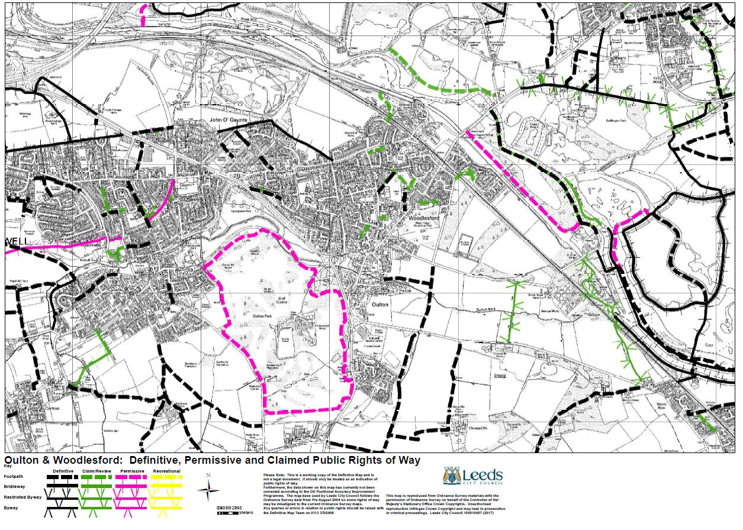

3.7 Business and economy (BE)
Policies
Purpose: Seek to make Oulton and Woodleford an attractive location for business growth, where this is appropriate to the locality | BE1: New business and employment development
Objectives addressed
To encourage development of all forms that is sustainable in terms of its impact upon our natural and built environments, our community and our economy.
To develop new facilities for the community that meet currently unmet needs and that are run for and serving our local community.
To assist the relevant authorities in developing sustainable traffic and transport plans that seek to reduce congestion and enable movement around, in and out of the communities.

  - 3.7.1 BE1: New business and employment development
Employment opportunities for local people within the neighbourhood area are very limited both in number and type of occupation. Current vacancies identified are all within the service industry (Beer and waiting, customer assistant, coffee shop assistant, deputy manager at local hotel).
The largest employers (only 4 and none of these employ large numbers) in the area are all within service sector ( car sales and repairs, hotel, sports centre, supermarket ). There are very few employment opportunities for young people, few, if any, apprenticeships in the area, no training opportunities and no local advice centre in the forum area.
Two public presentations, aimed at informing the community of research findings and resulting proposals, and two major public consultations were carried out. In order to attempt to get the maximum possible footfall these were held at the same time as a local council election and a European Election in an adjacent room in the same premises. The following responses were noted:

- should any major industrial or commercial developments within the area be resisted?
A total of 322 agreed (36 disagreed) that any major industrial or commercial development within the Forum area should be resisted.
- should new business start up units be welcomed?
A total of 263 agreed (63 disagreed) that a number of new, small business start up units would be welcomed.
A total of 86 agreed (20 disagreed) at the first consultation that they would welcome new small commercial/retail outlets (shops and restaurants) thereby giving a greater degree of diversity. At the second consultation 182 agreed but 71 disagreed although no comments were forthcoming as to why this larger number disagreed. One possibility is that the second consultation took place in the smaller Woodlesford area which has few shops and services and very restrictive parking opportunities.
- should the plan facilitate and encourage working from home with appropriate support in the way of advice and information?
A total of 206 agreed (29 disagreed) that this was a good idea. National figures provide further evidence of increasing numbers of people working from home.
A total of 331 agreed (7 disagreed ) with the need for local centres for people to obtain information/guidance on personal development.
Although the latter is not a planning issue, finding and allocating land and buildings within the local from which these service might be offered, is. It is clear that Site Allocations wishes to use most, if not all vacant land for housing.
- should the plan promote the provision of allotments in the area?
A total of 305 agreed (2 disagreed) on the provision of local allotments which could provide produce for a locally held Farmers market.
- should there be better broadband speeds and mobile telephone coverage?
A total of 309 agreed (12 disagreed) that improved Broadband and mobile telephone coverage in the Forum area is desirable and should be actively sought.
- should the plan promote development of local tourism opportunities?
Encourage the development of local visitor/tourism opportunities, e.g. a Woodlesford Lock and canal side visitor information centre/café. The local canal moorings in Woodlesford attracts visitors from many parts of the UK and with better facilities would provide a starting point for many local attractions otherwise unknown (e.g. Rothwell Country park, RSPB St Aidan’s, Nature Reserve, Pennine Trail spur). A total of 343 agreed (8 disagreed) with the development of this facility.

BE1: New business and employment development
New business development is welcomed in the village centres identified in Policy DBE2 and illustrated on the Policies Map where this:
- Provides greater diversity in the commercial/retail sectors (shops, restaurants).
- Provides new small "start-up units" for businesses.
- Encourages the development of a local visitor/ tourism economy, particularly in canal corridor locations.

3.8 High Speed Rail (HSR)
Policies
Purpose: Seek to reduce the adverse impacts of HS2 as it runs through the neighbourhood area towards Leeds city centre. | HSR1: Managing the impact of the development phase  HSR2: Design, community and the landscape
Objectives addressed
To encourage development of all forms that is sustainable in terms of its impact upon our natural and built environments, our community and our economy.
To assist the relevant authorities in developing sustainable traffic and transport plans that seek to reduce congestion and enable movement around, in and out of the communities.

  - 3.8.1 Managing the impact of the development phase
On 30 November 2015, the government announced a proposed way forward on Phase Two of HS2 and on 15th November 2016 the government announced the preferred route for Phase 2b. Detailed maps of this route have been published and available at https://www.gov.uk/government/collections/hs2-phase-2b-2013-route-announcement-documents.
Phase Two forms a ‘Y’ shape from the West Midlands up towards Manchester and the North West and up towards Leeds and the North East with proposed stations in Leeds, the East Midlands and Sheffield Meadowhall.
It is anticipated that Phase Two of HS2 will begin operating trains around 2033 as part of the integrated HS2 network and with the rest of the UK rail network. The Government wants part of Phase Two – the route between the West Midlands and Crewe – to open in 2027, six years ahead of the rest of Phase Two.
The neighbourhood area is affected both by the direct route into Leeds, as well the line traversing the area north-south, that extends the route towards York. Both routes impact on the Neighbourhood Area. As the line heads through Woodlesford, the current plan is for the line to drop into cuttings and a tunnel at Water Haigh Park, emerging north of the area for its final journey into central Leeds.
Notwithstanding the merits or otherwise of the HS2 project, if the line is directed through (or under) Woodlesford there are considerable and justifiable concerns about noise, pollution, traffic and other disruption resulting from the construction phase.
Key objectives noted in the Sustainability Appraisal undertaken by Temple-RSK for HS2 are endorsed by this Neighbourhood Plan:
      - To maintain or where possible enhance existing landscape character; and
      - To maintain or where possible enhance existing townscape character.

HSR1: Managing the impact of the development phase
During the period leading up to and during construction through the Neighbourhood Area, the developer and their contractors should seek to limit adverse environmental impacts upon the community and its environment. To this end, prior to the period in question, the developer shall:
- develop a sustainable development policy setting out defining principles regarding all aspects of operations and how potential impacts will be avoided or mitigated in respect of all areas where there is potential for impact, i.e.
- agriculture, forestry and soils;
- air quality;
- climate change;
- community;
- ecology;
- electromagnetic interference;
- health;
- historic environment;
- land quality;
- landscape and visual;
- major accidents and disasters;
- socio-economics;
- sound, noise and vibration;
- traffic and transport;
- waste and material resources; and
- water resources and flood risk.

- Engage with local authorities and other stakeholders to identify additional potential regeneration opportunities within the Neighbourhood Area.

  - 3.8.2 Design, community and the landscape
HS2 has the potential to be highly visible in the landscape. The community has expressed clear concerns about this and desire to see the route, if it is to be located in the neighbourhood area, blended into the landscape as far as is possible. Ultimately, that could mean tunnelling the line in its entirety (original plans anticipated viaducts as being the most likely means of bringing the line through).
However, if tunnelling is only a part of the eventual engineering solution, then all other means should be explored to minimise visual and noise pollution. Additional infrastructure known to be associated with the engineering works could include:
- Electrical substations.
- At any tunnel portal, emergency services area - 550m2 minimum - plus access roads.
- Passing places – i.e. extra loops of track that allow maintenance trains to be placed alongside mainline so trains can pass, and to push broken down trains into.
- Noise baffles – at upto 3m high.
The table below sets out, in the view of consultants employed by HS2, the major potential impacts on the stretch of the line impacting upon the Neighbourhood Area:
Table 1: Major and moderate potential adverse affects of HS2.
Route Description/ Impact Overall | Landscape/ Townscape Impacts | Visual Impacts
Major adverse (--) | Major adverse (--) | Major adverse (--)
Methley Lanes to Garforth (HSL17B)
At Methley Lanes the mainline route north would continue on viaduct over the M62 then run onto embankment up to 14m high and into shallow cutting through land between the confluence of the Rivers Calder and Aire. North of Methley Park it would emerge again onto embankment and 2.2km long viaduct over the River Aire and floodplain, passing between the eastern edge of Woodlesford and a sewage works and oil storage depot. The viaduct would generally be around 20m high but locally, north of the river, up to 29m high.  At Swillington the route would run on low embankment west of the village and into cutting north and east past Garforth. Here the route would initially parallel the M1 in cutting up to 13m deep, then pass onto 16m high embankment near Swillington Common and over the A63, then run again into cutting up to 20m deep near the Grade II Listed Barrowby Hall. Passing north of Garforth, the line would be close to grade next the motorway. | North of Methley Lanes is a rolling, large scale, wooded farmland landscape. The wooded corridor of the Aire valley includes industrial uses such as the sewage works and oil storage depot as well as extensive areas of restored mineral workings and remnant parkland. Its appearance today is generally attractive, with diverse features including oxbow lakes and riparian woodland. North of the Aire is a landscape mainly of small arable fields and pastures, with urban fringe pressures in evidence, but also with pockets of unspoilt parkland and woodland, such as in the Barrowby area.  Where the route runs through the Methley Park estate north of the M62, the new embankment would intrude on the landscape locally and there would be some woodland loss cumulative with the Leeds spur, resulting in a moderate adverse impact on landscape character.  At the crossing of the River Aire, the long, high viaduct structure would have a direct impact on several areas of riparian woodland and lakes and a moderate to major impact on landscape character. The impact would be major were it not for the presence of extensive existing tree cover in the surrounding area.  At Swillington the embanked route would have a moderate impact the character of the small river valley to the west of the village. Further north the high embankment near Swillington Common and the deep cutting near the Grade II Listed Barrowby Hall would fragment attractive farmland and woodland with a further moderate impact on landscape character and affect the setting of listed Barrowby Hall. | In the vicinity of Hungate Lane, users of the Leeds Country Way would be affected by visual intrusion by high embankment.  The viaduct crossing of the River Aire, due to its height, would have localised moderate or major visual impacts on users of the Trans Pennine Trail, the Leeds Country Way, the Aire and Calder Navigation and the fishing lakes at Swillington Park. One of the most sensitive locations on the Navigation, Lemonroyd Marina, would be bypassed. Visibility would often be contained by trees.  A small number of residential receptors in the Yew Tree Drive area on the eastern outskirts of Woodlesford, 250- 350m from the route, would have views of the viaduct, seen partly through trees, a moderate to major impact.  Further north, visual impacts would generally be moderate. Residents on the western edge of Swillington would have some views of the route in the valley below. A small number of residents at Swillington Common on the A63 would experience visual intrusion from the embanked route close by. At Barrowby Lane, the route in cutting and on embankment to the south-west would adversely affect the southerly views of walkers on the Leeds Country Way.
Moderate adverse (-) | Moderate adverse (-) | Moderate adverse (-)
Methley Lanes to Hunslet (HSL21/ HSL22)
At Methley Lanes the Leeds spur would rise onto embankment up to around 18m high north of the M62, then veer north-west and cross the HS2 mainline on a short viaduct. It would run into 17m deep cutting through woodland east of Clumpcliffe and onto a 9m high embankment, crossing over the A639 and then Oulton Beck on a short viaduct. Close to the eastern outskirts of Oulton the route would enter deep cutting and bored tunnel under Woodlesford.  North-west of Woodlesford the line would emerge from tunnel and cut and cover tunnel to run at grade along an existing rail corridor north of Rothwell Country Park. It would continue west initially at grade, passing under the M1, then in cutting and retained structure through industrial areas at Stourton and along the existing rail corridor to Hunslet. | North of Methley Lanes is a rolling, large scale, wooded farmland landscape, with unregistered parkland, areas of former opencast workings, and arable farmland. Further north and west the River Aire corridor near Woodlesford is part of Rothwell Country Park (restored mineral workings). To the west, towards Hunslet, industrial land uses predominate.  The high embankments of the grade-separated junction just north of the M62 would intrude locally on the landscape around Hungate. There would be a direct impact on several areas of woodland around Methley Park (cumulative with the mainline, just to the east). However the surrounding larger blocks of woodland would help to contain the wider landscape character effect of the deep cutting here. On the eastern outskirts of Oulton the tunnel approach and portal would again result in some woodland loss and change in landscape character, but this would not be widely visible due to the area’s existing wooded character. These impacts would be moderate.  West of Woodlesford, where the line would emerge from tunnel and follow the existing rail corridor through to Hunslet, any landscape character impact would generally be limited to some loss of existing lineside tree cover. | In the vicinity of Hungate, users of the Leeds Country Way would be affected by visual intrusion by high embankment.  Motorists and users of footpaths (including the Trans Pennine Way) east of Oulton would experience localised, mainly minor visual impacts from views of embankment and parts of the tunnel portal. However there should be little visual impact on residents of Woodlesford or Oulton Conservation Area.  West of Woodlesford there is likely to be a moderate effect on some views from the nearby Aire and Calder Navigation and Trans Pennine Trail, but this will depend on extent of tree loss in the area between the rail and river corridors. Rothwell Country Park may also be affected by any realignment of the existing railway on its northern edge.

HSR2: Design, community and the landscape
The promoter and the nominated developer(s) will seek to ensure that:
- Design contributes to the government’s pursuit of sustainable development, as set out in the National Planning Policy Framework, which involves seeking positive improvements in the quality of the built, natural and historic environment, as well as in people’s quality of life, with reference to the following elements where impacts are possible:
- agriculture, forestry and soils;
- air quality;
- climate change;
- community;
- ecology;
- electromagnetic interference;
- health;
- historic environment;
- land quality;
- landscape and visual;
- major accidents and disasters;
- socio-economics;
- sound, noise and vibration;
- traffic and transport;
- waste and material resources; and
- water resources and flood risk.

- Design of all visible elements of the built and landscaped environment are sympathetic to their local context and to the environment and setting in respect of the local community;
- The design is developed through engagement to seek peoples' views and ideas on the aesthetic design of the visible buildings and permanent structures.

Map 5: High Speed Rail preferred route 2017 - Leeds Metropiltan spur (1)
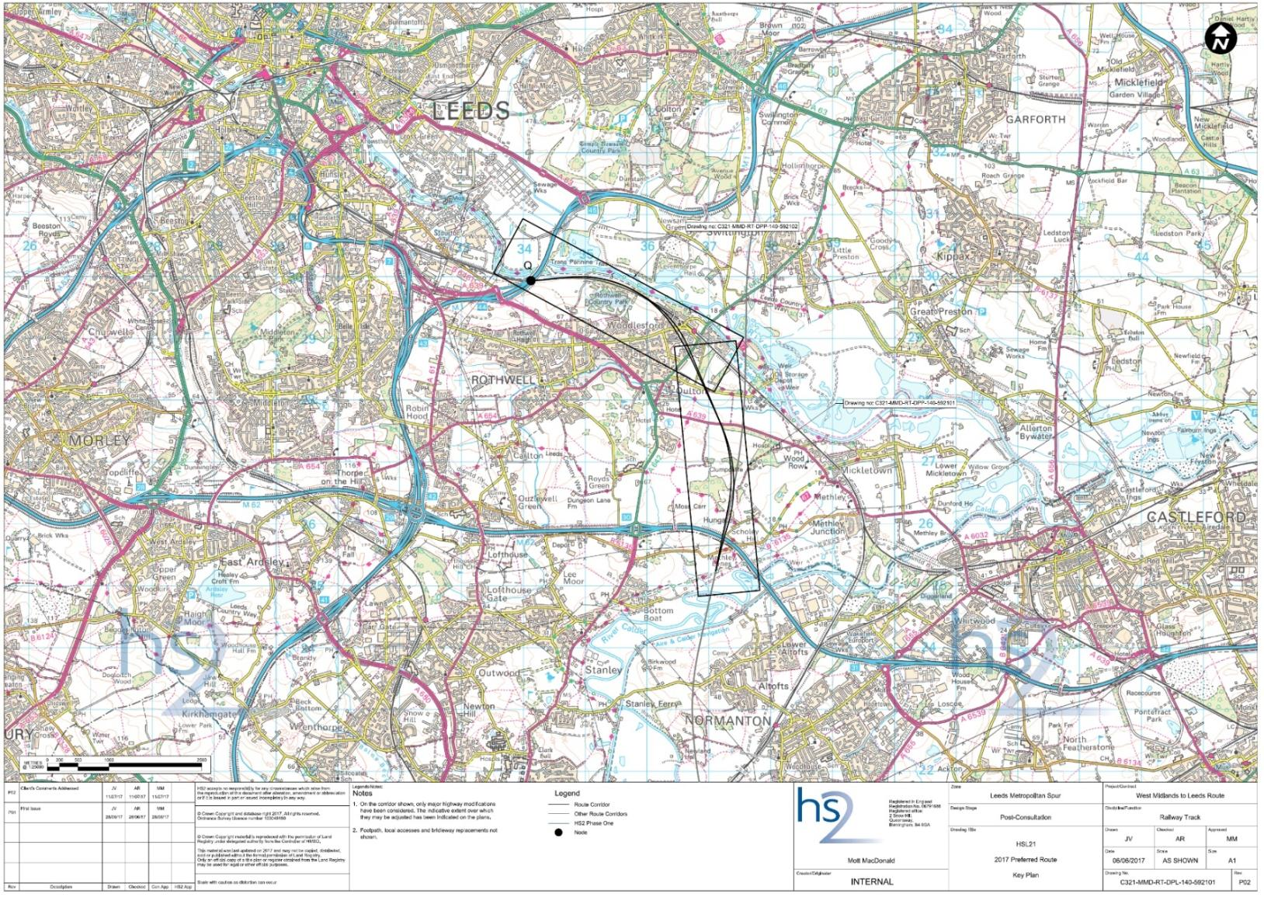

Map 6: High Speed Rail preferred route 2017 - Leeds Metropiltan spur (2)
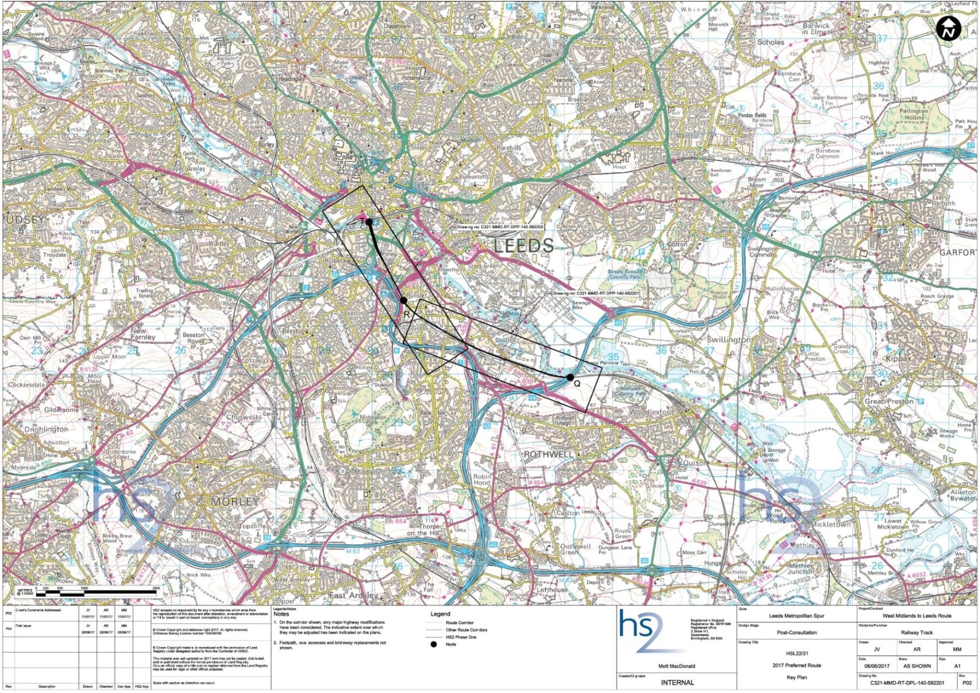

3.9 Policies map
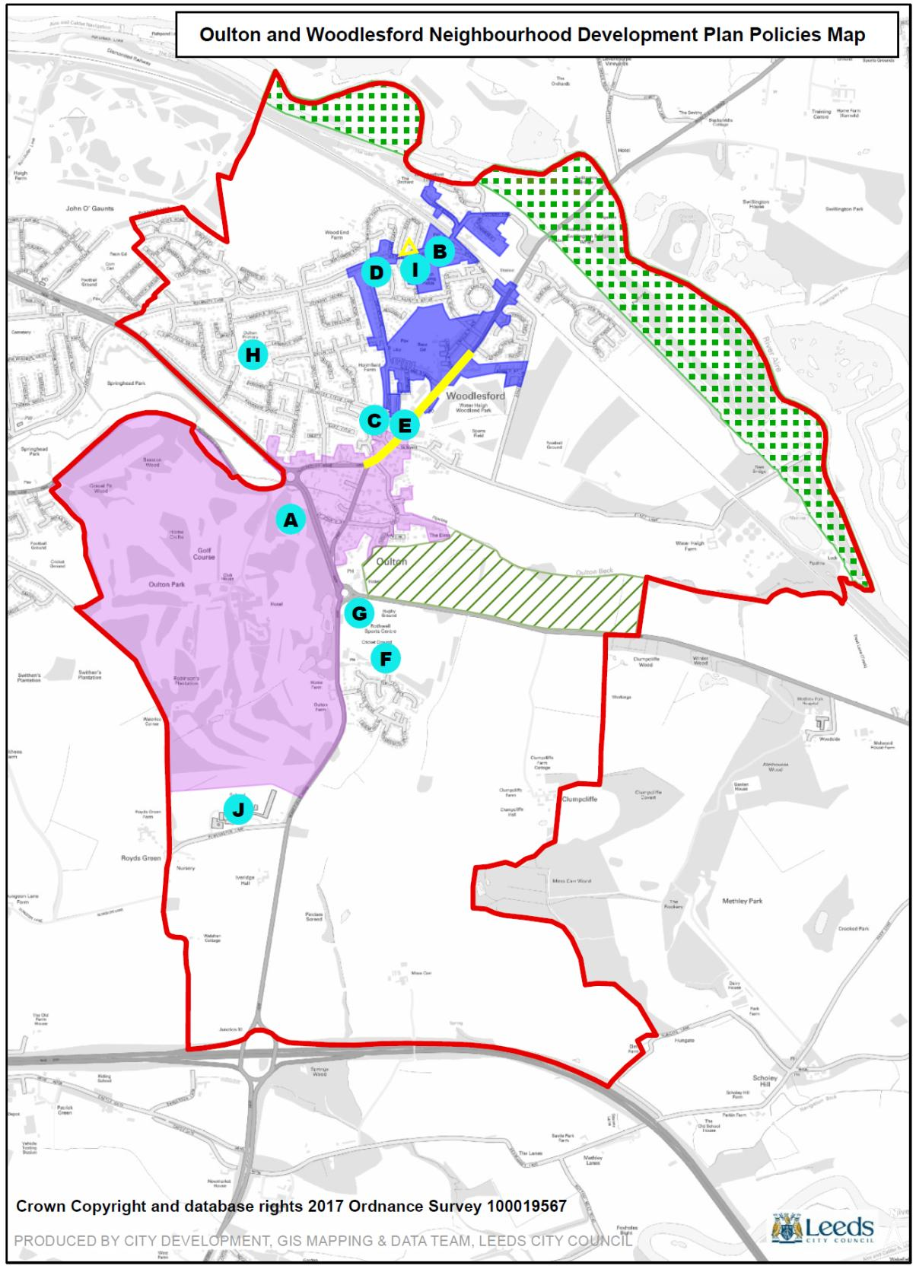

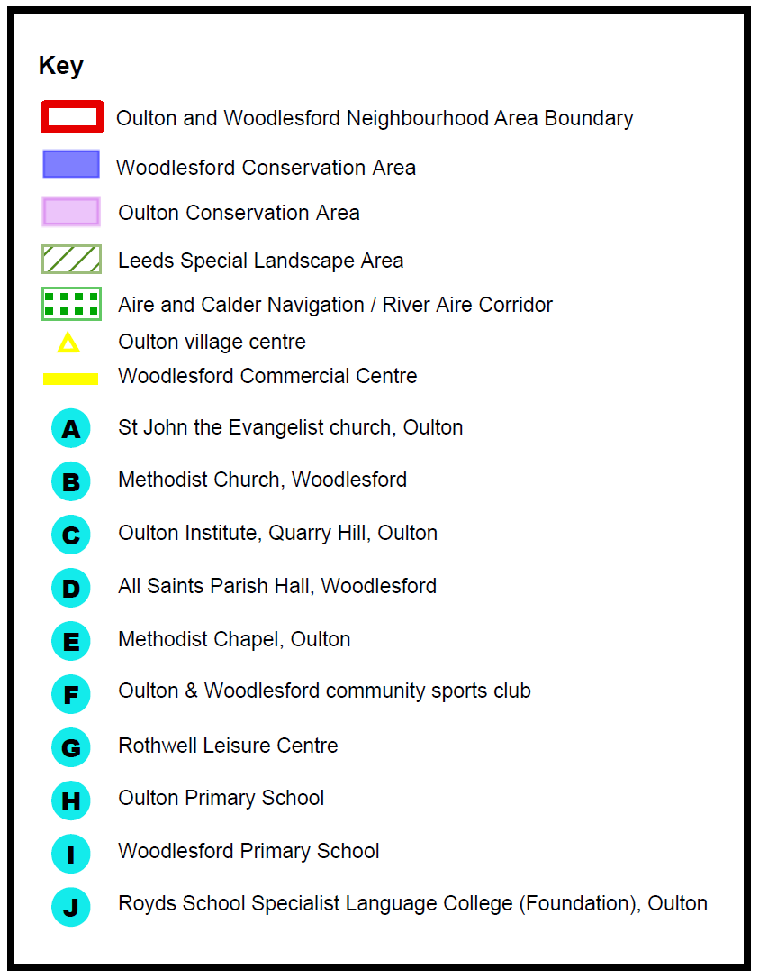

Projects and aspirations

The vision, objectives and policies set out in the Plan need to be delivered through positive planning and a complementary set of projects which are set below as aspirations for the Forum to drive forward with stakeholders and in discussion with the communities involved. The following aspirations and projects will be delivered over the period of the Plan through a combination of public, private and voluntary efforts, including deployment of Community Infrastructure Levy receipts for the Neighbourhood Area.

VISUAL
- Continue improvements to all green open spaces which are identified in the area.
- Continue the improvements taking place at the Woodlesford Recreation Ground with definable entrances with gates, gateway features and tree planting. Define boundaries to the Recreation Ground with more tree planting.
- Identify trees that should be protected by Tree Preservation Orders (TPO).
- Tidy the old quarry site on Quarry Hill; investigate restoration and possible status as a Nature Area. Improve the visual appearance of the land in front of Quarry Hill terrace
- Investigate opportunities for planting street trees to verges, particularly on North Lane.
- Add tree planting in the green space on All Saints Road. Plant trees/shrubs in verge at Junction of All Saints Drive with All Saints View (subject to highway assessment).
- Landscape around the Toby Carvery open space.
- Retain front gardens. Where parking areas are provided, they should be an absorbent surface and sufficient space retained at the front and sides for planting.
- Landscape and visually improve the grass verges on Holmsley Lane.

MOVEMENT
- Improve access for all on Public Rights of Way (PRoW), Maintain PRoW by regular walking and management of signs, stiles, gates etc. Add more interpretation boards.
- Improve cycle attractiveness and safety wherever possible. Form a footpath/cycle path connection to/from the Maltings.
- Investigate possibility of traffic calming and traffic management with more controlled crossings and cycle paths on Aberford Road, Calverley Road and Leeds Road.
- The canal towpath needs regular maintenance and an all-weather surface. Artwork/seating areas and interpretation boards would further enhance the route.
- Investigate means of restricting use of Eshald Lane as a through route.
- Improve parking for shops on Aberford Road.
- Parking for the station is limited leading to street parking. Investigate the possibility of additional off-street parking near the station.

STREET SCENE
- Carry out a quality audit of street clutter applying the principles of Manual for Streets and remove/consolidate where appropriate, to improve the visual experience whilst maintaining safety. This should include an audit for blind and disabled provision, including drop kerbs.
- Remove all redundant street signs.
- Ensure footpaths and rights of way are kept clear of hedges and greenery.
- Protect local shops, village pubs, cafés, restaurants, takeaways, community halls and places of worship, by registering them as assets of community value.
- The Clown House on Aberford Road requires painting and some restorative work.
- Investigate the necessity of or improve the quality of protective railings on Holmsley Field Lane.

CONSERVATION AREAS
- Investigate the opportunities to replace the concrete fence to Oulton Hall and Park alongside A642.
- Landscape the old entrance gates to Oulton Hall and prevent car parking to the area.
- Replace coping stones to low stone wall along Oulton Lane.
- Replace fences with stone walls where possible to improve the visual quality in the Conservation Areas.
- Improve the design and appearance of the bus shelters on Calverley Road, at the bottom of Leeds Road and by St John’s Street. These are at present, at odds with the Conservation Area character and would be improved if constructed in stone.
- Complete the painting black of lamp posts in the Conservation Areas.

COUNTRYSIDE
- Continue to resist inappropriate development in the countryside.
- Screen views of the oil depot at Fleet Lane which detracts from the rural character.
- Seek to repair and maintain the Trans Pennine Trail where it has been diverted away from its original alignment due to collapsed pilings along the banking.

GENERAL
- Investigate opportunities to increase the number of allotments.
- Improve broadband coverage, speeds, and mobile telephone coverage.

5.0 Delivering the Plan

The Forum’s constitution, approved at a Special General Meeting held on 12 January 2014, and subsequently by Leeds City Council, was adopted unanimously at the Forum’s second AGM on 27th April 2014. The constitution states that the objectives to the Forum are:

- to agree a long term vision for the Oulton and Woodlesford Neighbourhood Area.
- to promote and improve the social, economic and environmental well-being of the Oulton and Woodlesford Neighbourhood Area.
- to represent the people who live, work or carry out business in the Oulton and Woodlesford Neighbourhood Area.
- to produce a Neighbourhood Plan for the Oulton and Woodlesford Neighbourhood Area in conformity with the local development plan and the national planning policy framework.

With the adoption of this Plan, the first and fourth objectives will have been achieved, at least for the time being. However, in order to ensure that future developments in the Forum’s area, are in accord with the Forum’s Plan, there will be a continued need for the vigilance of the Steering Committee. The Committee will also continue to pursue its second and third objectives. In the future, the Neighbourhood Plan will need revision, which again will be a task initiated by the Steering Committee.

The Forum will therefore continue to hold at least one General Meeting each year, at which officers and members of the Steering Committee will be elected. It is to be hoped that in the future new members will join the Steering Committee so that there is a continued programme of renewal. It is likely that monthly meetings of the Steering Committee will continue to be necessary. To ensure our membership is informed of the business of the Steering Committee, we will continue to use the Forum’s website and develop the Forum’s use of social media.

APPENDICES

Appendix 1 Character Areas Assessment

Appendix 2 Key views

Appendix 3 Non designated local heritage Assessment

Appendix 4 Local Green Spaces Assessment

Appendix 5 Community facilities Assessment

Appendix 6 Supporting evidence

Appendix 1: Oulton and Woodlesford Character Areas Assessment

The Oulton and Woodlesford Neighbourhood Plan will have statutory status, forming part of the Local Development Framework and will be used to determine planning applications and guide planning decisions within the neighbourhood area. The Oulton & Woodlesford Design Statement and the Conservation Appraisals are key background documents and form part of the evidence base for the Neighbourhood Plan. The aspirations feed into the vision for the future of the area which the Neighbourhood Plan will provide and it will continue to provide guidance for development policies.

This document sets out, in brief, the key components of each of the identified character areas; the aspirations for policies in each area; and what are described as ‘high level actions for improvements’ – i.e. important projects. The Character Areas described in brief are those identified and delineated as part of the Design Statement process and are shown below for reference:
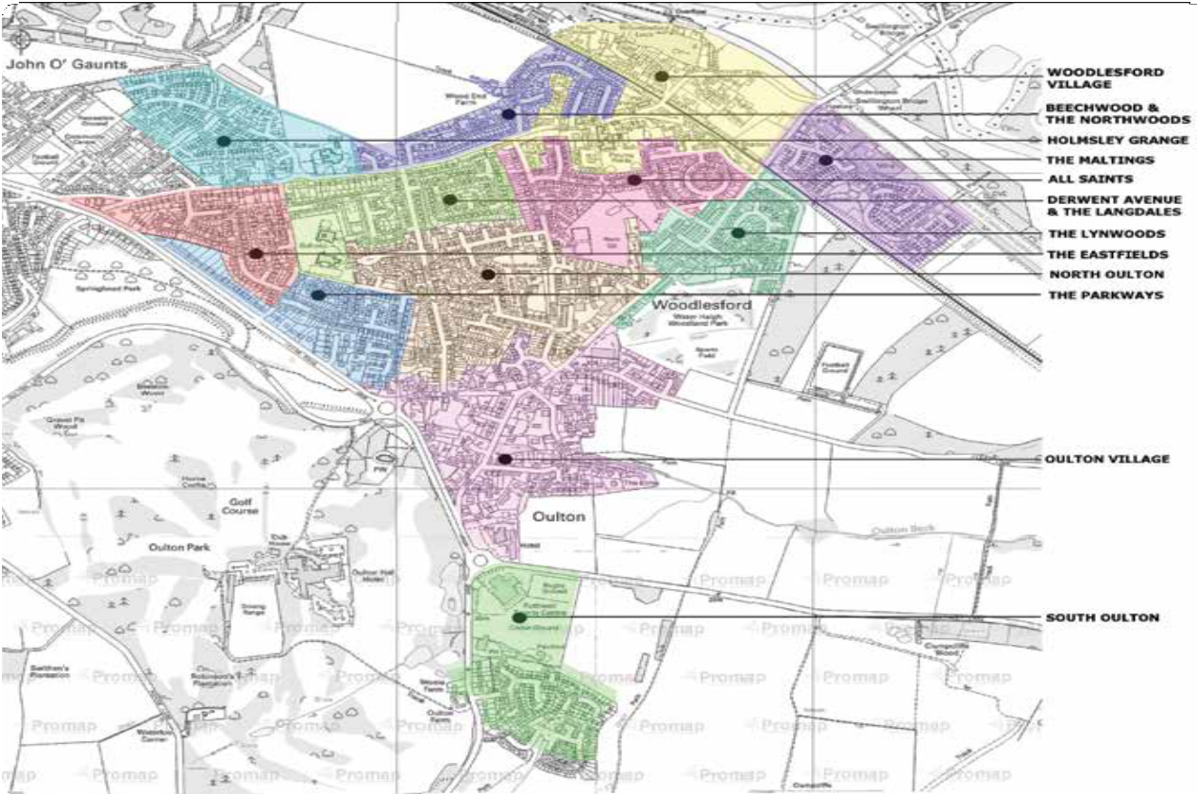

- Architecture: an overview

The older buildings in Oulton Conservation Area and the older part of Woodlesford Conservation Area provide the village with a sense of its history and are valuable heritage assets. The Appleyard Arbor houses in various parts of the villages are good examples of the better architecture of their period. Gradual organic growth over the decades has created a varied street pattern that gives the villages a distinctive character.

Aspirations for Neighbourhood Plan policies
- Future development and growth should respect local architecture and heritage assets.

High Level Actions for improvement
- Undertake a study of the street scene and street furniture; develop a design code to harmonise the street scene and street furniture in the two villages
- Carry out a quality audit of street clutter applying the principles of Manual for Streets. Remove/consolidate where appropriate to improve the visual experience whilst maintaining safety.

- Landscapes and streetscapes: an overview
Green Infrastructure is defined as a network of multi-functional green space, both new and existing, both rural and urban, which supports the natural and ecological processes and is integral to the health and quality of life of sustainable communities. Green infrastructure permeates all parts of the built, farmed and natural environments.

Aspirations for Neighbourhood Plan policies and supporting actions
- Landscapes

- Large, mature trees in gardens provide a soft backdrop for views within and into the village.
- Policy to identify trees for protection through Tree Preservation Order status outside the Conservation Areas.
- Policy to improve the availability of sports and recreation facilities at the Recreation Ground and other locations.
- Policy to improve and increase the number of allotments in new locations
- Policies to continue improvements at Woodlesford Park: definable entrances with gates, gateway features and new trees.
- Investigate opportunities for planting street trees where appropriate.
- Improve access for all on footpaths, e.g. from Beechwood to the canal and new footpath from The Locks.
- Streetscapes
- Provide good quality new cycle parking facilities at the station, linked with new cycling routes/canal walks/walking infrastructure.
- Improve walk/cycle attractiveness and safety wherever possible with more information boards and improved footpaths.
- Improve parking at the station.
- Improve parking for shops on Aberford Road.
- Investigate the possibility of controlled crossings on the A639 at strategic locations.
- Investigate ways of reducing traffic volumes and speed on Aberford Road through the Oulton Conservation Area.
- Investigate traffic calming measures on Pottery Lane to reduce its use as a rat-run.
- The junction of Fleet Lane with A642 has large radius bends for lorries exiting and entering; consider reducing the radii, providing the opportunity for more planting, slowing vehicles and increasing safety.

- Oulton Village

The variety of simple but good-quality detail in the design of the historic buildings is typical of the area. Buildings use stone and hand-made brick for walls and for slate roofs. Boundary walls of stone or brick, with a variety of heights, line the roads and gardens are well landscaped with mature trees. Access to countryside and local shops and facilities is convenient.

Aspirations for Neighbourhood Plan policies
- Policies to preserve, enhance and strengthen the Conservation Area in line with the Oulton Conservation Area Appraisal Management Plan
- Policy to protect gardens from inappropriate development particularly in the Conservation Area

High Level Actions for improvement
- Introduce further traffic calming and more crossings on Aberford Road and Calverley Road
- The replace of fences with stone walls to improve the visual quality
- Replace of the damaged concrete fence to Oulton Park alongside the A642

- Woodlesford Village
The historic buildings remaining in the old village are an important reminder of the past. The availability of the few shops, school, chapel and other facilities and the proximity to Woodlesford Station are important assets.
Views to the north east across to Temple Newsam from Church Street, can be glimpsed down the streets leading from it and the narrow, tree-lined lanes at Applegarth and Pottery Lane provide an attractive arcadian quality.
The proximity of the canal and access to walks along the tow path is a further asset.

Aspirations for Neighbourhood Plan policies

- Policies should look to preserve, enhance and strengthen the Conservation Area in line with the Woodlesford Conservation Area Appraisal Management Plan.

High Level Actions for improvement
- Parking at the station and the school is restricted leading to street parking. Actions to provide additional off-street parking near the station and at the school.
- The canal towpath needs regular maintenance and potential for an all weather surface should be sought. Artwork / seating areas and interpretation boards would further enhance the route.

- Pottery Lane

The land between the railway line and the canal west of Aberford Road and on either side of Pottery Lane, has been allocated for residential development for many years. Part of the area has been developed: The outline approval (12/00798/OT) on the site includes a Design Code which was written in consultation with the local community who should be similarly consulted on any further and detailed proposals for the site. As a result of the re-routing, the currently vacant land effectively forms five sites: Site A between the new and old routes of Pottery Lane; Site B on the slope between Pottery Lane and Woodlesford Station; Site C between Pottery Lane and the New Farmers Hill development; and Sites D and E between Pottery Lane and the Canal.

Aspirations for Neighbourhood Plan policies
- Policy to support the design code and future development along Pottery Lane should involve the community.

- Beechwood and The Northwoods
Woodlesford Village centre is within walking distance and there is footpath access to canal and to Rothwell Country Park. There are dramatic views across the Aire Valley to Temple Newsam.

High Level Actions for improvement
The two actions below will be addressed through the Green Space policy to protect and enhance local green spaces.

- Grass areas off Northwood Park would benefit from tree/shrubs. They are well used for ball-play, but judiciously planted trees could complement that use.
- The footpath link to the canal can get overgrown in summer reducing its use; it needs more regular maintenance.

- The Lynwoods
The central green spaces by Eshald Mansion are an attractive feature and there are good links to Water Haigh Park and Woodlesford Park via Eshald Lane. The stone detailing and stone boundary walls to the 19th century terraces on Eshald Place and Aberford Road are important elements in the townscape. The allotments east of Sydney Street are a valuable asset to the community.

Aspirations for Neighbourhood Plan policies
- Frontages to shops on Aberford Road could be improved as part of a policy to develop the road as a more cohesively designed retail centre.

High Level Actions for improvement
- The former Ritz Cinema/Clown House needs to be improved by painting and maintenance.
- Policy to restrict visitor parking outside the former Ritz Cinema/Clown House and on Lynwood Crescent
- Eshald Lane is used as a short-cut – there is a footway only to part of the Lane making it narrow and dangerous. Investigate means of restricting use as a through route.
- The original stone wall to the Eshald Mansion estate, along Eshald Lane is an important historic feature which should be preserved.

- The Maltings

The estate is close to Woodlesford station and relatively close to facilities along Aberford Road and Woodlesford village. The footpath link to Eshald Lane provides good access to Water Haigh Country Park and there is an attractive and useful green space at the centre of the estate.

High Level Actions for improvement
- Reduce the height of the wall in front of the listed gatehouse which detracts from its elevation.
- Flooding takes place in the green space on occasions and the storage capacity of the surface water sump should be investigated.
- Avoid parking on pavements.

- All Saints

The hedges to front gardens, where they remain, are an important feature in the street scene and the grass verges to All Saints Road give a welcome softness to the road edges. The green space in All Saints Road is a valuable asset. There is easy access to Woodlesford Recreation ground.

Aspirations for Neighbourhood Plan policies
- Add tree planting in the green space on All Saints Road. This will be addressed through the Green Space policy to protect and enhance local green spaces

High Level Actions for improvement
- Plant trees/shrubs in verge at Junction of All Saints Drive with All Saints View (subject to highway assessment).
- Restore hedges to front boundaries where these are missing.
- Avoid parking on the verges especially where off road space is available.

- North Oulton
The trees in the old quarry are a positive landscape feature. The tree at the junction of Oulton Lane, Quarry Hill and Midland Street closes the vista down Oulton Lane.

Aspirations for Neighbourhood Plan policies
- Old quarry area – investigate restoration and possible status as a Nature Area.
- Development policy and design brief for Cooper’s garage and workshop area, if allocated in the Leeds Site Allocations Plan.

High Level Actions for improvement
- Landscape the land in front of Claremont Street houses.
- Improve appearance of car park at side of Midland Hotel.
- Investigate the necessity of or improve the quality of protective railings on Holmsley Field Lane.
- More trees, shrub and bulb planting on bare grass areas; tidy up fences, walls and gardens.
- Improve entrances to Woodlesford Rark.

- The Eastfields

The trees at junction of Eastfield Crescent and Eastfield Drive are an important element in the street scene. There are panoramic views looking south from Eastfield Crescent. The design of houses and mature garden landscape in the Gipsies provide a high quality visual environment here. The trees in front gardens along Holmsley Lane are an important element in the street scene.

High Level Actions for improvement
- Avoid double parking in Eastfields.
- Investigate improving the footpath from Eastfield Crescent to Leeds Hill and the link to Eastfield Drive.

- Derwent Avenue and Langdales
The open aspect of Langdale Road gives a sense of space.

Aspirations for Neighbourhood Plan policies
- Policy to improve and enhance local green spaces. This will be addressed through the Green Space policy to protect and enhance local green spaces

High Level Actions for improvement
- Investigate the possibility of imaginative traffic calming/varied paving on culls-de-sac such as are included in Home Zones. Reduce speed limits.
- Provide tree planting on open frontages in Langdales.
- The mixture of front garden brick/stone walls/fences/ hedges look unsightly.
- Recycling area at end of Langdale Road has an unattractive appearance and could be re-designed.
- Investigate the possibility of providing tree planting to verges, particularly North Lane.
- Avoid parking on verges.

- The Parkways
There are panoramic view from Leeds Road to the south and west and the view of church spire and Oulton Park from Parkways Avenue provides an interesting vista. The tall mature trees round Calverley Court are a prominent and attractive backdrop to a number of views in the area.

High Level Actions for improvement
- Consider the possibility of a cycle path on Leeds Road.
- Consider controlled crossings and traffic management on Leeds Road at strategic points.

- Holmsley Grange
The estate is generally well- landscaped, giving an attractive appearance and the traffic-speed management features in the road surface are successful and help to create an attractive street scene. The large area of open space is a valuable asset and there is good access to Rothwell Country Park.

Aspirations for Neighbourhood Plan policies
- Improve demarcation of the entrance to the Country Park at Pickpocket Lane through Green Space policy.

High Level Actions for improvement
- There could be a landmark feature to the roundabout at entrance to Holmsley Grange.
- Investigate means of preventing the use of motorbikes on Pickpocket Lane.
- More tree planting would help to screen blank brick walls, particularly close to the entrance to the estate.
- DIY Fencing along the rear of gardens facing the green space is not attractive and could be improved by replacing with more robust fencing or by adding substantial hedge/shrub planting on the outside.

- South Oulton
The stone walls at the entrance and along the main road are an attractive feature and the central green space on Oulton Drive with links to the countryside is a valuable asset. The sports centre, sports club and sports fields provide sporting facilities for the wider community.

High Level Actions for improvement
- Avoid parking on pavements.
- Retain front gardens. Where parking areas are provided, they should be an absorbent surface and sufficient space retained at the front and sides for planting.
- Improve appearance of prefabricated garages on exposed corner plots by screen planting if re-building is not possible.
- Restore hedges replaced by timber picket fences which are showing signs of age.

- Oulton Hall & Park and St John the Evangalist Church
These provide a significant historic landscape and high quality historic architecture at Oulton Hall and St John’s Church. There is a valuable non-resident use of Oulton Hall facilities alongside a permissive perimeter path and the Hotel Leisure club which is open to non-residents. The pay and play golf course is a further valuable asset.

Aspirations for Neighbourhood Plan policies
- Policy to enhance and protect boundary treatments throughout the area but with particular reference to Oulton Hall and the refurbishment of the old entrance gates.
- Policy to protect the important views of the Hall and gardens.

High Level Actions for improvement
- Replace the concrete fence to the A642 which detracts from the quality of the landscape it encloses.
- Seek the removal of car parking at original gate which is inappropriate.
- Install interpretation board showing the history of the Park at the entrance.
- Replace coping stones to low stone wall along Oulton Lane.

- Water Haigh Country Park
High quality and well laid out leisure facilities including sport, cycling and walking which offers good access to the canal and towpath with local and national footpath links. There are pleasant countryside connections to Leeds and Castleford.

Aspirations for Neighbourhood Plan policies
The following issues to be identified under Green Space Policy for local green spaces –
- More interpretation boards.
- Form a footpath/cycle path connection to/from the Maltings.
- Screen views of the oil depot which detracts from the otherwise rural character.
- Seek to repair and maintain the Trans Pennine Trail where it has been diverted away from its original alignment due to collapsed pilings along the banking.

Appendix 2: Key views
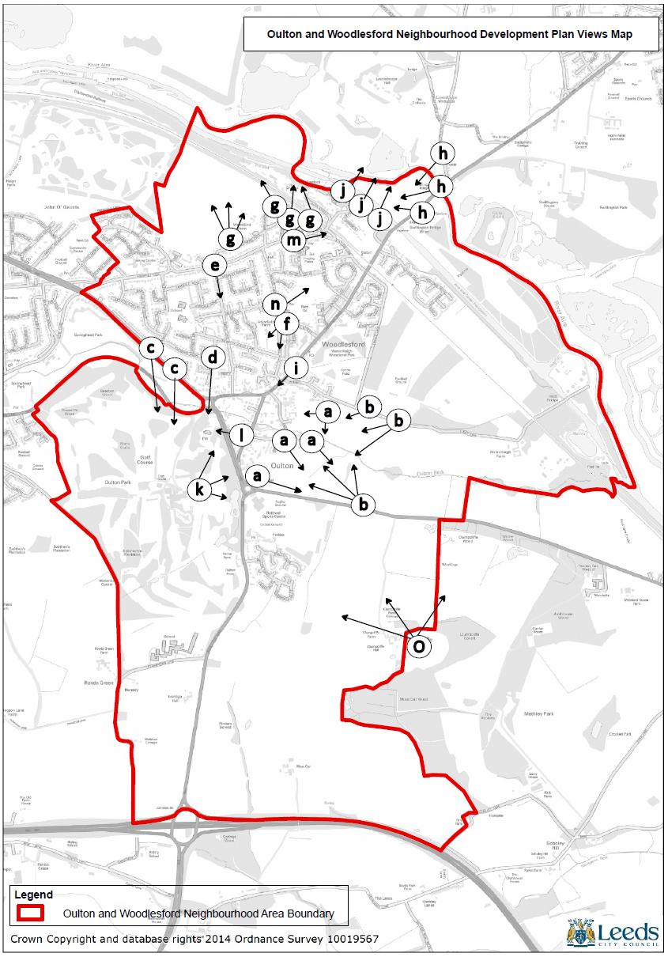
Appendix 3: Non Designated Local Heritage Assessment
This appraisal is particularly significant to the overall assessment of the built character of Oulton and Woodlesford, since, apart from Oulton Hall and St. John the Evangalist Church placed in their Repton landscape setting, the listed buildings of the historic township are not read in isolation from their neighbours. There is a constant interplay between listed buildings and those which define their context thereby creating distinctive localities within the township as a whole. Thus ‘non-designated heritage’ is presented in ‘groupings’ – streets, yards, courts and other types of space – whilst still making reference to specific buildings.
The original version of this Assessment with references can be found in the NDP evidence base.
(i) Calverley Road.
In the early 19th Century, the new alignment of Calverley Road at its Western end was set on the gateway, lodge and bridge which led to the driveway to Oulton Hall. This route crossed the new Leeds-to-Barnsdale Bar turnpike road of 1822. Nos. 1, 3, 5, 7 & 9 Calverley Road form a pleasantly relaxed alignment on its north side containing a spur drive to Holly Cottages and Willow Cottage. Oulton sandstone (exposed and with some over-rendering) is the principal wall material and the roofs are stone slated.
(ii) Willow Square: nos. 1 – 3 and 4 – 6 .
This next spur off the south of Calverley Road is defined by cottage terrace or grouped forms in similar materials to the first group. It is united by sandstone sets and flagged paving.
(iii) Chapel Yard, the former Wesleyan Chapel and Bentley Square.
These form a third group along the nouth side of Calverley Road, again in similar materials to the first two, except the chapel manse and a bay window element to no. 4 Bentley Square are in smooth red local brick. There is some Welsh slate roofing too.
No. 1 Chapel Yard is a remaining cottage with stone slate roof, probably 18th century or early 19th century. Rendered in rough cast with ‘scoring’ to smooth render to represent stone patterning. The old chapel building with attached tower element was completed in 1875, replacing an earlier chapel on the same site. In 1949 it was sold to become in turn, a paint factory, a design studio and finally apartments. Nos. 2 and 3 and 6 and 7 Bentley Square are stone cottages with stone slate roofs, again probably 18th century or early 19th century, built possibly for workers at Croft Farm (4 and 5 Bentley Square – listed).
(iv) The historic Manor Lane remains in the form of another ‘spur’ – here off Aberford Road. No. 9 is named Rose Villa, a fine survival whose exposed gable displays the ‘shadow’ of a former row of cottages which linked the Villa to the rear of the shops (nos. 15 & 17) on Aberford Road. These form a bold pair of two and three storeys of commercial space. (Again there is a shadow of the Manor Road terrace on the rear of the paired structure.) The present Old Masons’ Arms public house replaced an historic version on the same site.
(v) The Oulton Institute anchors a strong locality at the foot of Quarry Hill. The modern dwellings in stone and brick to the rear of the Institute, that form the Leventhorpe group, connect the old village and the Institute area by the use of these two materials and a well-arranged layout.
(vi) Between the Institute and the circular setting for the War Memorial (itself an elegant design in Portland stone) is a mixed group of buildings forming a singular identity. It begins with a tall, short terrace of houses opposite the Institute at the bottom of the line of Quarry Hill. The Institute is in red brick and has a Welsh slate roof. Quarry Hill turns to meet Aberford Road, revealing an historic stone cottage and the gable end of 67 Aberford Road – a former barn, then converted to a joiner’s workshop with a further 1960s/70s conversion and extension as a joiner’s workshop and family dwelling. This successfully anchors the setting for the recently-closed (2016) Methodist Chapel, facing Aberford Road (no. 63). The chapel was built as the United Methodist Free Church in 1860 – a place of worship for over 150 years.
(vii) Terraced Housing, Council Housing and 20th Century Housing.
The terrace of houses opposite the Oulton Institute is one of many good variations of this type of housing across Oulton and Woodlesford. They include the fine tall stone and blue slate roofed terrace along Holmsley Lane (nos. 97 -103) with bay windows and tall chimneys. Stone, brick or stone front/brick back terraces enrich Quarry Hill, Midland and Claremont Street, Oulton Lane (New Woodlesford), the Eshalds, the Airdales and along the whole length of Aberford Road in various stretches.
Council house types from the 1920s, 1930s, 1950s and 1980s are present in various successful and well-built forms and layouts: North Lane, Green Lea, Albert Road, All Saints , the Avenues of the ‘New City’ (Holmsley Lane/John o’ Gaunts) and the restoration of the former Coal Board Estate of Aberford Road (with recent extensions of housing types) – are all expressions of commitment to good standards of housing provision.
From the 1960s to the present, local builder E. Appleyard & Sons/Arbor Homes developed private housing types and structures anticipating many of the themes of contemporary sustainability-inspired Canadian models of highly insulated prefabrication of timber structures for housing. Asymmetrical roof composition and jettied cedar-clad upper storeys have been included in adaptations to topography in localities such as the Eastfileds, The Croft and Pottery Lane.
(viii) St.John’s Street/Farrer Lane, Oulton.
From the west end of Calverley Road in an arc extending to the former Oulton School at its east end, a strong linear village structure developed across many periods. Punctuated by the Three Horseshoes and New Masons’ Arms public houses, a string of historic and recent cottages, houses and short terraces evolves – mostly in sandstone with stone slate roofs, but also with rendered, red brick and half-timbered elements.
The sequence begins with nos. 2, 2a, 4, 6 – 12 Calverley Road. Leeds Road offers 28 – 30, 32 – 36, 38 – 40 and includes St. John’s Yard and a former smithy. St. John’s Street has nos. 1 – 3, 9 – 11, whilst a spur up the main Aberford Road has a similar character in its cottages whilst having newer dwellings enhancing the setting of Springwell Grange, these included nos. 16 – 24 Aberford Road and the Briardene group.
Farrer Lane continues the curved, linear layout with a rich range of periods and materials establishing its character from half-timbered and 17th century stone buildings to an exemplar of new construction in traditional form, materialty and details at Brook Cottage, 26a Farrar Lane near Oulton Beck bridge.
(ix) Benjamin Wood Higgins
A local architect, who lived in Willow Cottage (no. 7 Calverley Road), Benjamin Wood Higgins designed very successfully in a late Victorian/Edwardian manner. In the latter style, and quite rare examples, he designed detached and semi-detached “villa” forms, five house in the upper part of Oulton Lane – all around 1912.
He also made a coherent whole of Oulton Institute, designed in three phases (including the Harold Hall) between 1893 and 1912.
(x) Oulton Vicarage and Woodlesford Vicarage with adjacent Parish Hall; Woodlesford Primary School.
With the support of the Calverley family in 1829 and the 1870s, both vicarages were built for the ‘new’ churches of St. John’s, Oulton and All Saints, Woodlesford. Lord Lowther and the local Crompton-Oddie family founded the church in Woodlesford. Both vicarages are tall, bold and high chimneyed stone structures, material echoed in the original part of Woodlesford’s church hall.
The 1870s (following the Great Education Act of 1870) also saw the construction of the stone-built, blue slate-roofed Woodlesford School and the Headmaster’s House (1879).
(xi) The steeply sloping Church Street, Woodlesford is, as with St. John’s Street/Farrer Lane in Oulton, the straight, linear defining form of Old Woodlesford It is punctuated at its top by the vicarage and at the bottom by the All Saints Church building and the Two Poiters public house. The top-most building is a tall, stone house (no. 7 Holmsley Lane) as it levels out at the top of Church Street.
As well as the school, the adjacent Wesleyan and Methodist Chapel and a very well-designed, effective 1960s/1970s shopping and service centre are placed at the mid-point of Church Street.
(xii) Applegarth Cottage and Applegarth House are set near the junction of Applegarth itself (now curtailed) and Church Street. The house is another fine stone building, standing proud.
Opposite Applegarth is Woodlesford village green – a defining and invaluable green space with mature trees, established fully in 2009 on the site of early street-side cottages.
(xiii) Several stone or rendered cottages and short terraces remain as significant fragments of historic Church Street: nos. 2, 7 – 13, 36/38, 42 – 45 and Oakdene set at the foot of Church Street and nos. 6 – 18 Highfield Lane (another spur of Church Street by the village school).
(xiv) At nos. 71 and 73 Church Street between the Two Pointers public house and the All Saints Church building, a building was designed in 1973 in new forms and new materials. It created a a dwelling on the street and above it and integral with it, a house overlooking the Aire Valley to the north-east. It responds to the sloping site and creates views of the gable and form of the All Saints Church building.
(xv) Pottery Lane and Station Lane, Woodlesford.
Just below the All Saints Church building, a dramatic steep descent takes place down to the Aire and Calder Navigation canal and flood plain of the River Aire. Here Pottery Lane and the slopes up to the Woodlesford rail station and railway cutting area are steep. On this sloping land, further examples of design in the idiom of modern architecture have been created between the 1960s and the present day. The houses of the various phases of 20th century design contrast with, but complement, the stone built terrace of cottages at the foot of Quarry Hill.
Also at the foot of Church Street, Station Lane turns off to the right (south) after its descent. This alignment relates to the cutting of the London, Midland and Scottish railway route from St. Pancras Station to Glasgow in the 19th century. Station Lane begins with former shops at the foot of Church Street together with surviving terrace houses in this location. It is punctuated be the Victorian ‘villa’ Laurence House (now a nursery facility).
Alma Street leads north from Pottery Lane on its historic line parallel with the railway cutting. It has a stone 19th century villa, Elm House, and surviving Victorian and later terraces (nos. 38 – 44 and 50 – 56). The former Boot and Shoe Inn (below the terraces, but above the canal) survives as terrace housing.
Above the station, near the lower, eastern end of Station Lane, the station master’s house is well-maintained as a tall Victorian echo of the railway era.
(xvi) Aberford Road meets the lower end of Station Lane below the Station Master’s House.
This “toll road” between Wakefield and Aberford, crosses the canal and River Aire by bridge and stone viaduct structures – over the ancient ‘Wood-less Ford’.
Through Woodlesford to the East and heading for Wakefield, it passes the listed house of the Bentley family – major brewers – before reaching the Co-op buildings, fine examples from 1899 and 1925, of the cultural and architectural genre. Also it passes a former cinema and the nearby survivor of quarrying and brick-making, the stone “work shed” of quarrying. Fine red brick and stone terrace houses and shops run along both sides of Aberford Road, reminders of the brewing, coal mining and quarrying eras of Woodlesford.
The Midland Hotel at the foot of Midland Street, with its art-deco hints, is a reminder of the eras of the new railway and early toll road coincidence in Woodlesford. Behind the hotel is Quarry Road leading to an early stone quarry. A large Victorian/Edwardian ‘villa’ of two dwellings with stone bay windows, was built in the base of the quarry. Called ”Sunnyside” when built, it is now known as Quarry House.
Summary Comment
The rich diversity of contexts for listed buildings reinforces the value of the designation of the Oulton and Woodlesford Conservation areas, and celebrates a wide range of characterful contexts. Throughout Oulton and Woodlesford is a unifying range of boundary walls: tall and low, in stone and brick, threading their positive way through the joint “township” of Oulton-cum-Woodlesford.
Iveridge Hall and Moss Carr farmhouse, barn and 18th “gazebo” are “outliers” from the historic villages, acting as connectors to the links and views from the ridge between Oulton-cum-Woodlesford and Stanley and Wakefield, both very historic and thriving from carefully considered conservation and new development.

Non-designated heritage assets: Oulton & Woodlesford
Street | Name/numbers | Type | Map ref.
Aberford road | 15 & 17 | Shops | 8
Aberford Road | 16 - 24 | Cottages | 31
Aberford Road | 67 | Cottage | 14
Aberford Road | 83 – 93, 112 – 116, 118 – 138 | Terraces | 22
Aberford Road | Briardene group | Houses | 32
Aberford Road | Co-operative Store | Shop | 57
Aberford Road | Former Cinema | Nursery facility | 58
Aberford Road | Former Methodist Chapel | Community use | 15
Aberford Road | Midland Hotel | Public House | 60
Aberford Road | New Masos’s Arms | Public House | 27
Aberford Road | War Memorial |  | 11
Aberford Road (to rear of no. 142) | Former stone work-shed | Commercial premises | 59
Airedales |  | Terraces | 21
Alma Street | 38 – 44, 50 - 60 | Terraces | 54
Alma Street | Elm House | House | 53
Alma Street | Former Boot and Shoe Inn | House | 55
Bentley Square off Calverley Road | 2, 3, 6 & 7 | Cottages | 6
Calverley Road | 1, 2a, 3,4, 5, 6 – 12, 7 & 9 | Cottages | 1
Calverley Road | Former Wesleyan Chapel | Flats | 5
Calverley Road | Willow Cottage | Cottage | 2
Chapel Yard off Calverley Road | 1 | Cottage | 4
Church Street | 2, 7 – 13, 18, 36/38, 42 – 45, Oakdene | Houses | 49
Church Street | 71, 73 | House | 50
Church Street | All Saints Parish Hall | Community use | 42
Church Street | Applegarth Cottage | Cottage | 47
Church Street | Applegarth House | House | 48
Church Street | Fromer Headmaster’s House | House | 44
Church Street | Two Pointers | Public House | 45
Church Street | Woodlesford School | School | 43
Claremont Street | 4 – 16, 18 - 28 | Terraces | 18
Eshalds |  | Terraces | 20
Farrer Lane | Brook Cottage, 26a | Cottages | 33
Farrer Lane | Former Greenland Farm | House | 25
Gypsy Hill, Gypsy Lane |  | Houses | 23
Holmsley Lane | 7 | House | 46
Holmsley Lane | 97 - 103 | Terrace | 16
Leeds Road | 28 – 30, 32, 36, 38 - 40 | Cottages | 28
Leeds Road | Former vicarage | House | 41
Leeds Road | Three Horse Shoes | Public House | 25
Leeds Road, St. John’s Yard | Former forge | Cottages | 29
Leventhorpe Way, Leventhorpe Court |  | Houses | 10
Manor Lane off Aberford Road | 9 | Cottage | 7
Midland Street | 3 - 11 | Terrace | 17
New Farmers Hill, off Pottery Lane |  | Houses | 51
Oulton Lane | Former vicarage | House | 40
Pottery Lane | 3 - 5 | Terrace | 52
Quarry Hill | 2 | Cottage | 13
Quarry Hill | 8 -14 | Terrace | 12
Quarry Hill | Oulton Institute | Community use | 9
Quarry Road | Quarry House, 2 – 6, 3 - 5 | Houses, terrace | 61
Robert, Kitchener, Buller & White Street | Stone terraces, former back-to-backs | Terraces | 19
St. John’s Street | 1 – 3, 9 - 11 | Cottages | 30
Station Lane | 18, former Station Master’s House | Houses | 56
Station Lane | Laurence House | Nursery facility | 52
The Croft, off Aberford Road |  | Houses | 24
Willow Square off Calverley Road | 1 - 6 | Cottages | 3

Appendix 4: Local Green Space Assessment
Working cross- reference | 1.Name and Location | 2.Size | 3.Adjacent to properties | 4. Community value | 5.Landscape value | 6.Historic value | 7.Recreational value | 8.Wildlife value
26 | Adjacent to no. 4 Midland Street |  |  | Garden maintained by Woodlesford in Bloom |  | None | Gardening | Wildlife habitat
31 | Albert Road amenity green spaces |  | Charles Grove |  |  |  | Childrens play area
25 | All Saints Road amenity green space
24 | All Saints Road/ Eshald Place amenity green space
21 | Allotments, Bernard Street |  | Eshalds, Lynwoods | Gardening |  |  | Gardening
34 | Allotments, Albert Road |  | Albert Road | gardening |  |  | Gardening
4 | South Oulton amenity green space |  | Oulton Drive/ Wordsworth Drive/ Sugar Hill Close
6 | Applegarth Manor amenity green space |  | Fleet Lane
8 | Calverly Road amenity green space |  | Calverley Road, Chapel Yard, Bentley Square | Gardening
18 | Canal tow path, Woodlesford lock to Lemonroyd lock |  | The Maltings, Aire and Calder Navigation. | Walking, Cycling, | Yes |  | Walking, Cycling, | Wildlife diversity, bird migratory route - Part of Aire valley green corridor
19 | Canal-side,from Woodlesford lock NW towards Leeds |  | The Locks, Pottery Hill, Aire and Calder Navigation. | Canal side, orchard, canal side beds, Wooded area with carved animals, bird viewing area | yes | yes | Walking, birdwatching, Cycling, gardening, fishing | As above
3 | Clumpcliffe amenity green space |  |  | Walking | yes
7 | Farrer Lane ammenity green space |  | Farrer lane/Stone Croft Court
15 | Fields to SE of The Maltings
35 | Green Lea amenity green space |  | adjacent to Oulton Primary School
32 | Holmsley Field Lane amenity green space |  | Parkways
2 | Iveridge Health Club grounds |  | Wakefiled Road | Fitness and Health
22 | Linwood Crescent amenity green space |  | Lynwood Crescent
30 | Northwood Park amenity green spaces |  | Northwood Falls/ Needless Inn Lane
5 | Oulton Community Sports Sports Club |  | Methley Lane/ Wakefield Road | Sport, walking, Social events |  | Originally a gift to the residents of Oulton and Woodlesford from the Calverly family | Rugby, Cricket, Football, Sub Aqua
1 | Oulton Hall Park | 110 ha |  |  | yes | Designed by Humphry Repton, 1809, Grade 2 listed on Register of Historic Parks. | Golf course, Angling
36 | Oulton Primary School playing field and grounds |  | Gipsy Lane/ Langdale Road | Sports and community events |  |  | Football, including local junior football team, athletics, | Garden for wildlife
9 | Oulton War Memorial |  | Fleet Lane, Aberford Road | Social area, Photography |  | Erected 1921 | Photography
38 | Pickpocket Lane |  | Needless Inn Lane | Gardening |  |  | Gardening, dog walking | Wildlife habitat
39 | Pymont Drive amenity green space |  | Pickpocket Lane to Eighth Avenue |  |  |  | Walking | Link to Country park
33 | Quarry Hill green space |  | Oulton Lane | Wooded old Quarry site |  |  | Dog Walking | Wildlife habitat
37 | Sherwood Way sports field |  | Pickpocket Lane |  |  |  | Childrens' play area, football pitch
23 | Station Lane, adjacent to Woodlesford Station. |  | All Saints Road | Gardening |  |  | Gardening | Wildlife habitat
20 | Sydney Street amenity greenspace |  | Sidney Street | Play area, social area
17 | The Malting, entrance |  | The Maltings, Aberford Road | Gardening |  | Adjacent to former brewery gatehouse, grade II listed. |  | Planted insect habitat
16 | The Maltings amenity green space |  | Maltings | Play area,gardening |  | The Maltings developemnt on the site of the former Bentley's Brewery.
14 | Water Haigh Park,  canal- and river-side |  | Aire and Calder navigation | Walking, Exercising dogs, bird watching, Photography | Area of outstanding natural beauty, comprising interconnected woodlands meadow hedgerows and wetland | None | Seating and Picnic area, nearby trans- Pennine trail | Habitat for deer, fox, owl, bat, butterflies, and dragon flies, sparrow hawk, skylark, songthrush, curlew, otters, birch, alder, oak, rowan, pine and larch
11 | Water Haigh Park, Eshald Woods |  | Eshald Lane | Walking, Exercising dogs, bird watching, Photography | yes | Former site of Water Haigh Colliery.Some remnants remain of railway track across Eshald Lane, canal-side staith. | Walking | As above
13 | Water Haigh Park, Fleet Bridge Woods |  | Fleet Lane | Walking, Exercising dogs, bird watching, Photography | yes | Former site of Water Haigh Colliery | Walking | As above
10 | Water Haigh Park, part adjacent to Eshald Lane, SE of buildings on Aberford Road. |  | Fleet lane, Aberford Road | Walking, Exercising dogs, bird watching, Photography | yes | Reclaimed from former quarry. | Walking | As above
12 | Water Haigh Park, West Yorkshire County and Rothwell juniors Football |  |  | Football, Social events in clubhouse |  |  | Football
27 | Woodlesford Park |  |  | Dog walking, sports, picnics, family area, socialising all ages | yes | None | Skate park, childrens' play area, fooiball pitch, bowling greens and pavillion. | Wooded area for wildlife
28 | Woodlesford Primary School Playing and Sports field; Garden |  | All Saints, opposite Beechwood | Sports and community events |  |  | Football,including local junior football team, athletics, | Garden for wildlife
29 | Woodlesford Village Green, Church Street, Woodlesford |  | Opposite Northwood Falls, adjacent to All Saints Parish Hall. | Public, walking, Gardening, Community events |  |  | Children play Carol singing  Relaxation.  Dog walking | Tree and planting including wildflower area.

Appendix 5: Community Facilities assessment
Places of Worship
- St. John the Evangelist church, Oulton. The church of the C of E parish of Oulton with Woodlesford. Currently closed following the theft of lead from the roof and subsequent water damage. Repair underway following funding from the Heritage Lottery Fund. Meanwhile the church is unusable and worship is transferred to the All Saints Parish Hall, Woodlesford. Once the church has been made weatherproof, the damage to the inside has been repaired and it is once again usable, there are plans to develop the building to allow wider community use. The community is engaged in this plan through the ‘Friends of St John’s’, upon which the Forum is represented.
- Methodist Church, Woodlesford. The church is now used by worshippers from Oulton and Woodlesford.

Meeting Places.
- Oulton Institute, Quarry Hill, Oulton. The Institute, which was founded in 1893, contains a large hall, two small meeting rooms and a kitchen, all of which are available for hire. These are heavily booked; regular renters include dance classes, yoga classes, charity coffee mornings, dog training classes, choir practice, and various community support groups, including the Forum. In addition to these, there are casual bookings, children’s birthday parties being a particularly popular use. The Institute is used as a polling station.
- All Saints Parish Hall, Woodlesford. The Hall, which was originally associated with All Saints Church, Woodlesford, became the parish hall for the combined parish of Outlon with Woodlesford, following the de-conconsecration of All Saints Church in 1993. The Hall comprises a large and a small meeting room and a kitchen, which are available for hire. The Hall is currently in use for worship while the church is being repaired. Ten different community groups make regular use of the hall and there are also casual bookings.
- Methodist Chapel, Woodlesford. As well as the chapel itself, there is a meeting room which has regular community use. This room is used as a polling station.
- Methodist Chapel, Oulton. This has recently been closed. It was previously used not only for worship, but also by community for various functions including a regular coffee morning (which has now moved to the Oulton Institute). The future of the building is not known. There is no land associated with the building and so no possibility of parking. The possibility of community use is being investigated.
- Midland House, Midland Street. This has a room used by various community groups including a Breakfast Club and a Gentle Exercise class.

Schools
- Oulton Primary School. Recently rebuilt. About 400 pupils.
- Woodlesford Primary School. About 475 pupils.
- Royds School Specialist Language College (Foundation), Pennington Lane, Oulton. About 1350 pupils.

Sports and recreation
- Oulton & Woodlesford community sports club. This sports club leases land from Leeds City Council and is the base for the following sports.
- Rugby League. This section of the club provides Rugby League teams from the age of 3 up to open age. There are around 250 junior members and 50 youth members. The 1st team play in the National Conference League division 1 and have around 50 senior players. There are also around 20 women in an Open Age side.
- Cricket. This section of the club runs cricket teams from the age of 9 up to senior level. There are 1st and 2nd XI that play in the Central Yorkshire Cricket League. The junior membership is around 60 and the senior teams have about 30 registered members.
- Sub Aqua. This section is affiliated to the Sub Aqua Association and has around 40 members
- Football. This is a relatively new section to the Sports Club and has 3 junior teams with around 30 members, 1 senior team with 20 members and 1 women’s team with 20 players.
- Rothwell Leisure Centre. This council-owned centre is a very important provider of sporting facilities for the area. It is used by the public, local sports clubs and groups and local schools; activities and facilities include:
- Swimming Pool for individual usage, the Kippax Swimming Club and police and local sub aqua clubs and local primary and secondary school swimming lessons.
- Main Sports Hall/Activity Hall for badminton individual and club use, netball, gymnastics including the Rothwell Gymnastics Club. 5-a-side football , judo and taekwondo clubs, fitness groups and mini tennis
- Fitness Centre. There are over 100 fitness machines available to the public. These are used on either an individual basis, in group sessions and can be adapted for the disabled. Uses include resistance work, cardiovascular workouts, cycling, weights and synergy fitness sessions.
- The Centre is regularly used by Royds School to broaden the School Physical Education programme

- Angling. The canal and river in Woodlesford are popular for angling. There are also fish ponds on the Oulton Hall Estate. These are not large, could be better maintained and have a problem with nearby parking. Since they are adjacent to the Rothwell Sports Centre it is hoped that an arrangement could be made for anglers to use its car park.

Accommodation

Accommodation in the Forum area ranges from the four-star luxury of Oulton Hall to bed-and-breakfast at local pubs (Midland Hotel and Two Pointers in Woodlesford and the New Masons Arms in Oulton). There is also a Holiday Inn Express in Oulton.

Appendix 6: Supporting evidence
The Neighbourhood Plan is built on a wide range of evidence sources. Much is the important evidence that has been provided through consultation and engagement with our local communities. The extent of this and its influence on the Plan will be set out in a comprehensive Consultation Statement to accompany our final Plan when it is submitted to Leeds City Council. The following table lists the key evidence sources other than consultation evidence, that has informed the Plan to date:
Document | Source | Date
Oulton Conservation Area Appraisal and Management Plan | Leeds City Council | 2010
Woodlesford Conservation Area Appraisal and Management Plan | Leeds City Council | 2011
Oulton Village Guide | The Oulton Society | Undated
Oulton and Woodlesford Design Statement | Leeds City Council | 2014
Neighbourhoods for Living | Leeds City Council | 2003
Pottery Lane Design and Access Statement | Peter Baker Associates | Undated
Leeds Landscape Assessment | Countryside Agency | 1994
Leeds Rights of Way Improvement Plan | Leeds City Council | 2009
Leeds Core Strategy | Leeds City Council | 2014

High Speed Rail: HS2 Phase 2b Preferred Route Sustainability Statement including Post Consultation Update Appendix C1 – Landscape, Townscape and Visual A report by Temple-RSK for HS2 Ltd (November 2016)

